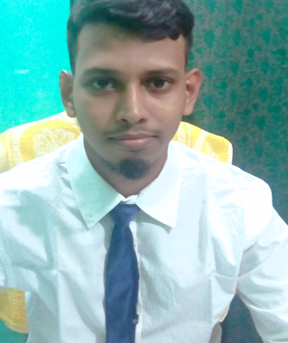
Curriculum Vitae
OF
Fahim Ahmed
CAREER OBJECTIVE:
To build up a career in challenging position where, creativity, a sense of responsibility, hard working ability and honesty will be appreciated.
PERSONAL INFORMATION:
Name : Fahim Ahmed
Father Name : Shahid Miah
Mother Name : Juana Khatun
Present Address : Shahjalal -56, Old Medical Colony, Sylhet -3100
Permanent Address : Shahjalal -56, Old Medical Colony, Sylhet -3100
Date of Birth : 01-04-1995
Religion : Islam
Marital Status : Unmarried
Sex : Male
Nationality : Bangladeshi by Birth
Moblie : 01685954270
EDUCATIONAL QUALIFICATION :
Exam Name | Passing Year | Result | Board/ University
S.S.C (Business Studies) | 2011 | G.P.A : 4.25 | Sylhet
H.S.C(Business Studies) | 2013 | G.P.A : 3.80 | Sylhet
Honors’ 4th Years | 2013-2019 | running | National University

LANGUAGE SKILLS :
Good Command in both Bangle, English
COMPUTER SKILLS :
I am Completed Digital Marketing Course As a Freelancer & web designer complete in Bangladesh computer council, sylhet.
(Fahim Ahmed)

