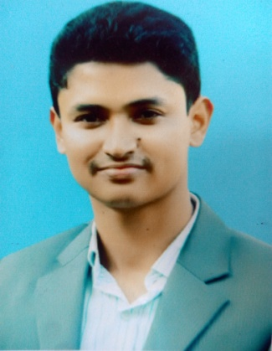
Curriculum Vita

MD. Shafi Chowdhury

E-mail : Shafichy1992@gmail.com
Contract No. : 01739-971162, 01630125530

EDUCATION QUALIFICATION

B.Sc Engineering
- Name of institute : Sylhet International University
: B Sc Engineering in ECE (waiting for final result)

Higher Secondary School Certificate (H.S.C.)
Institute Name : Modon Mohan College
Board : Sylhet
Group : Science
Result : G.P.A- 3.20
Year : 2012
- Secondary School certificate (S.S.C)
Institute Name : Hajee Abdus Satter High School .
Board : Sylhet
Group : Science
Result : G.P.A- 3.25
Year : 2009

PERSONAL INFORMATION

Father’s Name : Khasru Chowdhury
Mother’s Name : Rowshan Alom Chowdhury
Permanent Address :Khurum Khola R/A
Tuker Bazar ,Jalalabad, Sylhet.
Present Address : Khurum Khola R/A
Tuker Bazar ,Jalalabad,Sylhet.
Date of Birth : 09/01/ 1992
Nationality : Bangladeshi
Marital Status : Single
Religion : Muslim
Interests : Writing, Reading, Lecture, Traveling etc.
Relevant skill : (a) Computer skill :
MS office, Excel, Power point ,C+, Java, electronics semulatation.
(b)Language Skill:
Fluent in Writing & Speaking both Bangla & English
Experience :
IT incharge , SylhettimesBD (05/06/2014 to still now)
Staff Reporter, Daily Sylhet Surma(01/02/2013 to still Now)
Web: www.sylhetsurma.com

I promise you, all my information is authentic and prepare for any step.

Date:03/005/17

