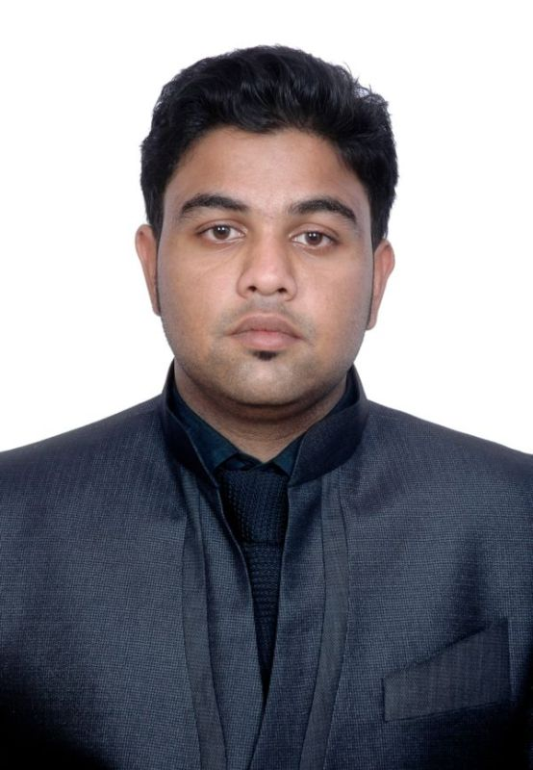
Curriculum Vitae
Adnan Islam
Bondhon C/25, Khasdobir, Sylhet-3100.
Contact No: +8801726659171
Email: adnan.islam121@gmail.com

Career Objective
To obtain a vast knowledge through which I can enhance my skills as well as I can acquire the ability to face a high level of challenges and get myself provided with varied experience and at the same time I would like to contribute my best to the organization.

Education
M.B.A. (Master of Business Administration)
Department : Business Administration
Major : Accounting & Information Systems
Passing year : 2016
University : North East University Bangladesh, Sylhet
C.G.P.A. : 3.46 (Out of 4)

B.B.A. (Bachelor of Business Administration)
Department : Business Administration
Major : Accounting & Information Systems
Passing year : 2013
University : Leading University, Sylhet
C.G.P.A. : 3.21 (Out of 4)

H.S.C. (Higher School Certificate)
Group : Business Studies
Passing year : 2009
College : Scholarshome, Sylhet
Board : Sylhet
G.P.A. : 3.90 (Out of 5)

S.S.C. (Secondary School Certificate)
Group : Business Studies
Passing year : 2007
School : Blue Bird High School, Sylhet
Board : Sylhet
G.P.A. : 3.63 (Out of 5)

Language Proficiency
Bengali: Good presentation and communication skills in Bengali.
English: Good presentation and communication skills in English.

Employment History
Position: Incharge & Manager (June 8, 2014 – September 30, 2017)
Company Name: Sylhet Board Mill
Company Location: BSCIC Industrial Area Khadim Nagar, Sylhet.
Department: Management
Duties/Responsibilities: Accounts monitoring, sells supervision, customer relationship management, bank accounts maintaining, stock maintenance, manpower organizing & supervision, documentation of related papers etc.

Competencies
Discipline and dynamic, energetic and enthusiastic, self motivated and innovative willing to take challenges and a perfect team player.

Computer Proficiency
MS Word, Power Point, Excel and Internet Application.

Extracurricular Activities
Volunteer at JAAGO Foundation.

Personal Details
Name: Adnan Islam
Father’s Name: Md. Ahiya
Mother’s Name: Rowshon Ara Begum
Permanent Address: Bondhon C/25, Khasdobir, Sylhet.
Nationality: Bangladeshi by birth
Religion: Islam
Date of Birth: March 3, 1991
Marital Status: Single
Sex: Male
Blood Group: O (+)

References
Md. Moshiur Rahman  Relationship Officer & Credit Analyst  IFIC Bank Ltd. Tultikor Branch, Amborkhana Sylhet.  Mobile No: +8801914874060 | Belal Ahmed  Advocate & Notary Public  63, Sagar Digir Par, Sylhet.  Mobile No: +8801714676236

I, hereby, declare that the above information is true, fair and fully updated.

Adnan Islam

