

Curriculum Vitae

Of
S. M. Shafiqur Rahman

Contact:
01713-078419
E-mail: rahman.shelsham78@gmail.com
Career Object:

To develop the career as a knitwear professional in challenging environment with excellent career development proposals where hard work, strict discipline and creative solving are the keys of success. I would like to utilize my capacity with sincere and honest service for better and effective.
Professional Experience:

- Employee: Shelsham Trading Co. Ltd.
Bangladesh Liaison office, (Hong Kong and UK Based Buying house) Position: Merchandising Manager (promoted)
Period: 1st July’2017-till now.
Handling Buyers: George clothing, Wal-Mart (Dept: Mens Bottom/Ladies Bottom/Older girl/Todder girls), Carrera Jeans (Italy), U.S. POLO ASSN. (USA), Inc Group Inc (Canada)

Major Responsibilities Include:
- Meeting with Customer.
Responsibilities:
- Costing with Customer & Order Negotiation.
- Price Negotiation with Manufacture
- Searching for Good Manufacturer.
- Searching for Good cloth mill in local and outside
- Follow–up order based on CP (Critical path)
- Production Follow-up up to shipment.
- All Communication with Customer and Manufacturer and fabric Supplier

• Knowledge of sourcing, manufacturing and costing
• Knowledge of global sourcing trends and strategies.
• Knowledge of time and action and production calendars.
• Strong negotiation skills
• Illustrates a dedication to meeting requirements of internal and external customers, responding to
all customer requests promptly and thoroughly.
• Strong communication skills including ability to work in a team environment, give honest, direct feedback and is a solid verbal and written communicator.
• Meets deadlines, prioritizes appropriately, copes well with change, and maintains composure under pressure.
• Is accountable for results, approaches obstacles proactively and looks for ways to resolve problems and issues.
Management skill Responsibilities Include:

- Employee: Shelsham Trading Co. Ltd.
Bangladesh Liaison office (Hong Kong and UK Based Buying house) Position: Sr. Merchandiser
Period: 15th April’2010-30th June’2017
Handling Buyers: George clothing, Wal-Mart (Dept: Mens Bottom/Ladies Bottom/Older girl/Todder girls)

- Employee: Complices Dhaka
Bangladesh Liaison office, France Based Company. Position: Sr. Merchandiser
Period: 1st July’2006-30th March’2010
Handling Buyers: Carrefour, Auchan, Galec, Group Casino & Cora (France)

- Employee: Grameen Knitwear Ltd
100% Export Oriented Knit Composite Manufacture (It's concern of Grameen Bank)
Position: Merchandiser
Period: 1st January 2002-30th June’2006
Handling Buyers: Guldenpfenning GmbH (Germany-Aldi, Lidl, TCM), Triton Textile Ltd. (Germany), Multiline GmbH (Germany), Juritex Import-Export GmbH (Germany), Horizonte textil GmbH, Jebsen & Jessan GmbH, Mascot International A/S (Denmark), Oxford (US), Cariban (France).

- Employee: Falcon International Ltd 100% Export Oriented Knit Composite Manufacture Position: Asst. Merchandiser
Period: 15th January 2001-31st December 2002

Handling Buyers: Centex (Italy), Alcot (Italy), Groupe Resistence Inc (Canada), Canada House (Canada), Star International (Spain), MC Yadra (Spain), NTD (Canada),
SLT (Canada).

Knowledge on Item:

  - Jeans Pant, Trouser, Skirt, Women Blouse, Jacket, Bermuda Pant, Cargo Pant, men’s & women’s Shirt.

  - Functional wear (X-static shirt), Sportswear (Cycling under shirt & pant, running shirt & pant, sky underwear with ringlet, Biker & undershirt) T-shirt, Polo shirt, Sweatshirt, Golf- shirt, Tank tops, Children wear, Jogging suits, under garments, etc.

Knowledge on Fabric:

- Denim, Canvas, Twill, Oxford, Ottoman, Corduroy, Gabardine, Poplin, Flannnel, Herrinborn.

- Functional and technical fabrics for sports wear (Coolmax, Coolmax Fresh Fx, Coolmax X- static, Top Cool, Coolbest, Polyamid Tactel, Coolplus, CVC (60:40), PC (65:35), CV (50:50), & Pima and Su-pima cotton). Pleated design rib & jersey, Whole range of Single jersey, double jersey, pique, Lacoste, Interlock, Rib, French terry, Fleece.

Training:
1. "Diploma in Fashion Merchandising” from Bangladesh Apparels Institute, New DOHS Mohakhali, Dhaka-1206, Bangladesh.
- "Diploma in Computer Graphics Designee" from ANANDA IIT.

Computer Skills:

- "Office Certificate Course" from GALAXY Computer Education, Dhaka.
- E-mail, Internet Operation skill

Language of Knowledge:

- Bengali (Oral & written)
- English (Oral & written)

Characteristic:

- Hardworking, Flexible Organized Enthusiastic, Non-smoker, Dynamic, Energetic, Devoted & Dedicated.

Academic Qualification:

Name of Institution | Board/University | Name of Exam | Section | Division/Classs | Year
Kazir Hat High School | Rajshahi | H.S.C | Science | First | 1993
Govt. Rajbari College, Rajbari | Dhaka | S.S.C | Science | First | 1995
Govt. Bangla College, Dhaka | National University | B-com | Commerce | Second | 1999
Dhaka College, Dhaka | National University | M-com (Management) | Commerce | Second | 2001

Personal Information:

Father's Name : Md. Katab Uddin Sarder
Mother's Name : Mrs. Laily Begum
Mailing Address : 540 (3rd floor, 4A), Monipur, Mirpur, Dhaka-1216.
Permanent Address : Village-Pikandi
Post Office: Kalikabari Police Station: Bera District: Pabna.
Date of Birth : 7th January 1978
Nationality : Bangladesh (By Birth)
Religion : Islam (Sunni)
Marital Status : Married
Ref. : Mr. Shaheenul Islam (Shaheen)
Director of Merchandising Windy group
Cell: 01713040676

Signature

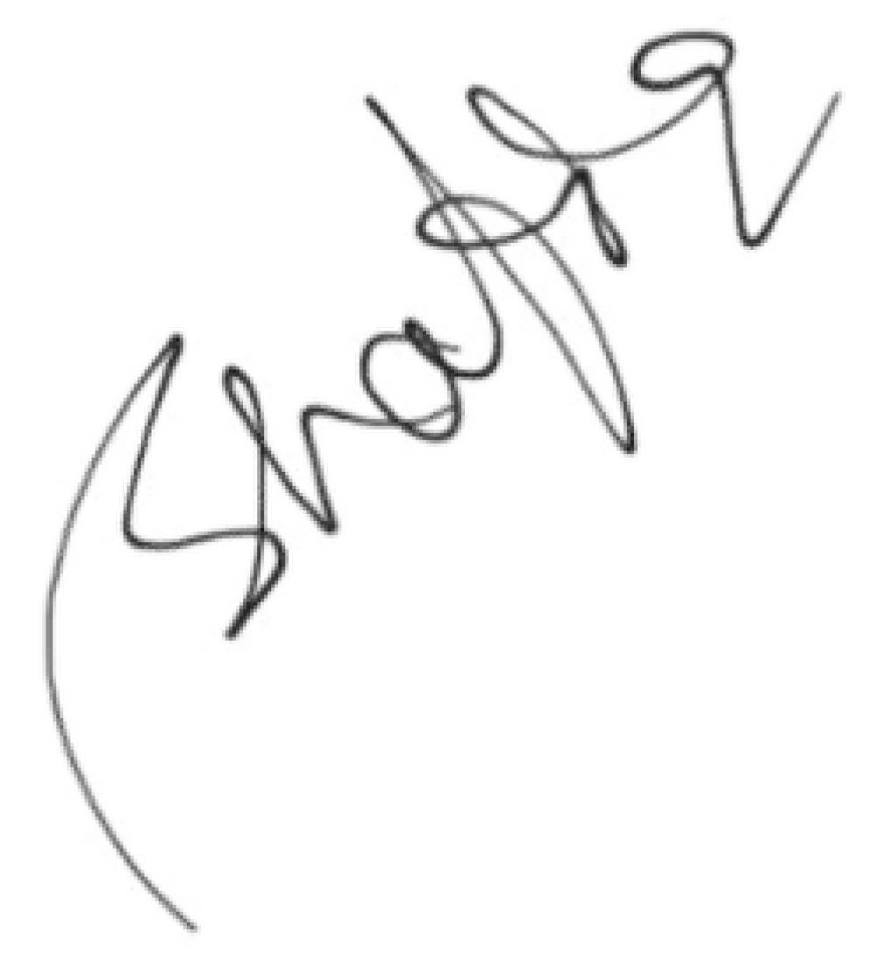
S. M. Shafiqur Rahman

