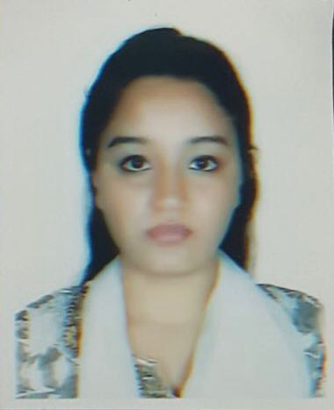
Hamida Khatun Jyoti
Address: 65/21, Nurani, Subidbazaar, Kolapara, Sylhet
Mobile: 01789504499/ 01620198396
Email: jutz24@gmail.com

Background:
- A caring and helpful individual with good communication, excellent team working skills as well as able to work independently.
- Practical skills such as using computer and working outdoors.
- Fluent in English, Bengali, Urdu and Hindi.

Career objective:
- To serve the organisation/nation in a responsible way.

Application info:
- Looking for Mid-Level job
- Available for permanent and full time job

Academic qualification

Exam title | Concentration/Major | Institute
O Level | O Level | Private
A Level | A Level | Private

Employment History and Experience:

•Teacher at Rabindra Nazrul Memorial School – January till December 2014 (1 year)
• Content Writer at Staff Asia Ltd sylhet (from 04-11-2017 to last January)

Interests and Specialisation

- Computer skills - Proficient with Microsoft Word, PowerPoint, Publisher and internet explorer

References

Personal reference: (brother)
Dr. Ali Mohammad Moynul
Northeast Medical College
Address: 65/21, Nurani, Subidbazaar, Kolapara, Sylhet
Mobile: 01712861872

Professional reference: (colleague)
Rehanul Hassan Bappy
Software Engineer at Staff India Organisation
Address: Shahi Eidgah, Sylhet
Mobile: 01675611855

