Mirjajangal, Sylhet
+8801940374834
protikdip2016@gmail.com
EDUCATION
CONTACT
OBJECTIVE
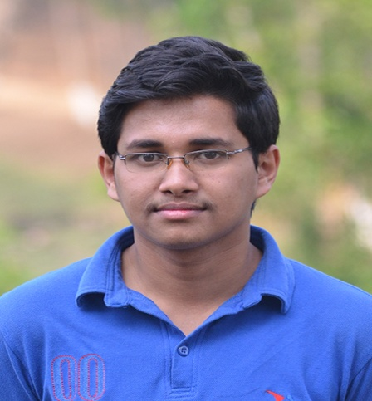

DIPANKAR BHATTACHARJEE

I aspire for a challenging position for a professional environment where I can enhance my skills and strengthen them in conjunction with organization goals.
Metropolitan University
Bachelor in Computer Science and Engineering
2015-2018
CGPA: 3.92

Higher Secondary Certificate
Sylhet Government College
2011-2012
GPA: 4.80


Secondary School Certificate
Sylhet Government Pilot High School
2009-2010
GPA: 5.00


Computer Proficiency

MS Word/PowerPoint
Adobe Photoshop
C++/Laravel/Bootstrap
Training Accomplished

Training on Graphics designing form LEDP

Training on Android application development form LICT

