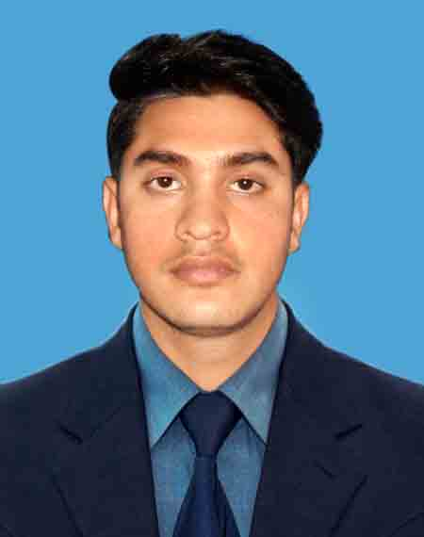
Curriculum Vitae

Md. Armanul Islam
Mobile No. +8801768329191, +8801862081469
E-mail:mdarmanulislam9191@gamil.com

CAREER OBJECTIVE
My goal is to become associated with a company where I can utilize my skills and gain further experience while enhancing the company’s productivity and reputation.

PROFILE
System Administrator adept at collaborating closely with the manager and undertake responsibilities of managing daily activities, directing operations and supervising staff in order to assist in actualizing firm’s monthly target, short term initiatives and long term goals and objectives.

EXPERIENCE-01:

Shah Amir Enterprise : Authorized distribution house of Grameenphone ltd.
Shah Amir Enterprise

- Post- IT/Business Support Officer (1st Feb, 2016 to Till now)

JOB DUTIES:
- Manage Enterprise log, Banking & Office Operational task
- Provide support, including Solving sales process and relevant reports.
- Provide assistance to users in accessing and using IT systems
- Rapidly establish a good working relationship with customers and other stakeholder, such as Retailer
- Provide support to IT systems including day to day operation, monitoring and problem resolutions for all of the SE/Sup/Retailer devices
- Coordinate team member for prompt various Sales Execution.
- Engage in Sales Executive Knowledge development activity.
- Operate the Distribution Management System (DMS).
Experience-02:
Chevron Clinical Laboratory ( Pte)Ltd.

(Chevron Clinical Laboratory (Pte.) Ltd. (CCLL) is one of the leading private healthcare providers in Bangladesh with a network of nine outreach centers located strategically across the greater Chittagong division.)

- Post: Computer Operator – X-ray Department (1st Feb, 2013 to 31th Aug, 2015)

JOB DUTIES:

- Responsibilities included problem detection and solving,
- Cline Data Entry .
- Maintains client confidence and protects operations by keeping information confidential.
- Support and service customer satisfaction .
EDUCATIONAL CREDENTIALS:
Exam Title | Concentration/Major | Institute | Result | PassingYear | Duration
BBS | Business Studies | Govt.city college,Ctg | Second Division | 2015 | 3 years
HSC | Business Studies | Patiya Govt. College,ctg | CGPA:4.2  out of 5 | 2012 | 2 years
S.S.C. | General | P.k Saberia Khalilia Islamia Sunnia Madrasha, | CGPA:4.94  out of 5 | 2010 | 2 years

Professional Training& Workshops
Training Title | Topic | Institute | Country | Location | Year | Duration
Diploma in Computer | Microsoft Office Package, Adobe Illustrator , Adobe Photoshop, Computer Hardware Setup and Windows Trouble Shooting . | Computer training Center UCD-Co Ordination Council NO-1, | Bangladesh | CTG | 2012 | 6 Months
Language Proficiency:
Language | Reading | Writing | Speaking
Bengali | High | High | High
English | High | Medium | Medium
PERSONAL CONVERSANT
Father's Name | : | Ahamed Noor
Mother's Name | : | Mumtaj Begum
Date of Birth | : | February03, 1995
Gender | : | Male
Marital Status | : | Single
Nationality | : | Bangladeshi
National Id No. | : | 19951516194000054
Religion | : | Islam
Permanent Address | : | Vill-Kaigram, P/o- Fazil Khar Hat,P/S- Patiya,Chittagong.
 |  | Reference: 01 | Reference: 02
Name | : | Md Mamunul Islam | Md Aubdul Latif
Organization | : | Bangladesh House Building Finance Corporation | Grameen Phone Ltd.
Designation | : | Manager | Territory Manager
Address | : | Shatkhira Branch, Shatkhira | Chatori chowmohony,Anowaram,ctg
Mobile | : | 01721110102 | 01711540116
Mail | : | mmislam2539@gmail.com | alatif@grameenphone.com
Relation | : | Cousin | Professional
REFERENCES:
CERTIFICATION:
I, the undersigned, certify that these curriculum vitae correctly describe me, my qualification and my skill.


Signature

Md Armanul Islam

