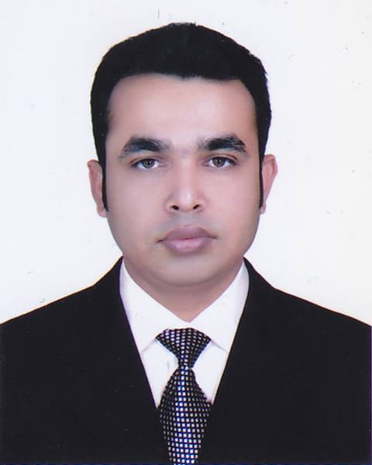
CURRICULUM VITAE
RAHAD AHAMMED
Baishtila Point
Airport, Sylhet .
Cell-+8801712114182
e-mail : rahad1188@yahoo.com

CAREER OBJECTIVE:
A professional with significant exposure of delivering business relevant ADMIN-HR specialized and my strong believe & career success have built the confident that I can add value to any business & be the partner of success. More than 6years experience with Local & Multinational Company. I am Passionate about Admin & HRM in MNC and local companies for the mid-level position and would like work on Organizational Development in near future.

CAREER SUMMARY:
Now Operation our Family Business(August 15, 2018- Continue)

Executive -Admin: (July 01, 2017 - August 14, 2018), Virgo Global
House # 1263, Road # 10, Avenue # 2, Mirpur D.O.H.S. Dhaka-1216

Asset Administrator -Admin Department : ( January 01, 2016 - January 31, 2017)
Transport Coordinator-Admin Department ( July 15, 2014 - December 31,2015)
Huawei Technologies (BD) Ltd. 59,61,Lutas Kamal Tower, Gulshan-1

Officer- Admin & Finance Dept.(August 02, 2012 - 12, July 2014)
Latex Creation Limited. 185, Green Road, Dhaka-1205

EXPERIENCE:
1. Executive -Admin, Virgo Global
DUTIES/RESPONSIBILITIES:
1. Supervising and monitoring day to day office administration work.
2. Proactively maintain office equipment like Generator, water pump, AC, Electronics goods, etc & Monitor over all security system.
3. Ensure all kinds of documentation of newly joined employee and issue new Identity card.
4.Organizes and facilitates meetings, conferences, and other special events; coordinates and attends committee meetings, and participates in committee discussions, as appropriate.
5. Work with suppliers and verify receipt of supplies, arrange requisitioning of office supplies in consultation with the Administrative Manager following office procedures.
6. Maintain stock records of stationery, refreshment and cleaning items for office and report back to the supervisor for necessary replenishment of all consumable items and office supplies.
7. Ensure Office over all cleanliness and hygiene.
8. Prepare salary, overtime and bonus of office staffs.
9. Arrange & prepare petty cash advance requisition form as required and help reconciliation of expenses for office expenditures such as House /Office/ Factory rent and other utilities.
10. Coordinate, supervise and evaluate all procurement activities consulting with the management.
11. To work on sourcing, vendor development, conduct negotiation meeting for purchases quality materials with competitive price.
12. Arrange and monitor the implementation of all security measures at the Head office and Factory offices.
2. Asset Administrator, Huawei Technologies (BD) Ltd
DUTIES/RESPONSIBILITIES:
1. Maintain office equipment assets and infrastructure - laptop / computer equipment telephone & internet equipment and service contracts office furniture and maintain records / office inventory of such items.
2. Filing documents- Maintain inventory record-keeping and ensure that it is updated regularly.
3. New join employees laptop provide systems transfer his/her name & log books registered.
4. As per policy laptop received from resigned employees or temporary services all information as recorded in systems with register book
5. As per dept/ employees requirement provided some equipments for their project/dept/ events with follow up & systems data updated
6. Every quarterly online check with systems all asset tracking recorded, which are missing or offline and on timely report to the management.
7. All asset recorded as per Asset management Tracking(AMT)
8. Every Month CT test sample report Publish to HQ management.
9. To daily checked & acknowledged employees expense claim,
10. To follow up the employees SSE & checked as per company policy.
11. To maintain asset personnel files & service records.
12. To prepare monthly attendance report. Overtime bill & others bill.
13. Maintain updated records, minutes, receipts and other relevant office documents including bank statements, and vouchers.
14. To supervise the house keeping security
15. To deal with purchase & procurement activities for office maintenance
16. Coordinate staff meetings logistics and activities for visitors and special events.
17. Operation Support and Track office supplies and submit request to restock as necessary.
18. Essential Duties and Responsibilities include the following & other administrative duties as needed.

3. Transport Coordinator, Huawei Technologies (BD) Ltd.
DUTIES/RESPONSIBILITIES:
1. Plan, organize and manage the work distribution, maintenance, repair and utilization of all the vehicle fleet of the area.
2. Coordinate the schedule for vehicle maintenance with management and staff to minimize service interruptions and arrange on time service plans.
3. Maintain by Wechat, email, sms & phone call and perform daily time to time any requirement for users.
4. To monitor and control pick-up and delivery of goods as per the set route and schedule deliveries in a cost efficient manner.
5. Update car list & Maintain Log Books for distance traveled km by each vehicle.
6. Manage and educate the driving staff to road safety, especially in heavy traffic or in bad weather and safety of passengers.
7. Monitor spending to ensure the expenses are consistent with approved budgets
8. Direct and coordinate for the activities of operations department in order to obtain use of equipment, facilities, and human resource
9. Improvise transportation solutions with existing fleet.
10. Measurement transport requirements and devise cost effective and feasible transport plan for the company.
11. Ensure by Wechat , email , sms and over phone & confirm users & drivers on timely.
12. Create Vehicle Rental PR, Fuel & OT Bill & Submitted time to time.

4. Executive (Admin& Finance) Latex Creation Limited
DUTIES & RESPONSIBILITIES:
1. To be collected for credit and cash collection against company sales.
2. Prepare weekly/ monthly/ yearly collection statement and do report to the Management.
3. Preparation of Vouchers.
4. Maintaining bank, inter-company, party & others reconcile
5. Check original invoices and bills prior to preparing voucher and also to ensure that all relevant documents are there.
6. Day to day office administrative work.
7. Fixed Assets & Equipments Maintenance.
8. Monthly Mobile Bill Statements Prepared & Bill Payments.
9. Prepared Meeting Munities, ID Card & Visiting Card
10. Preparing report and submit to the management time to time.

TRAINING &SEMINAR:
1. Planning Administration & Management., Bangladesh Agricultural University, Mymensingh
2. Seminar on Importance of Security Services in Modern Business.
3. New Generation Seminar `Skills Change Lives`. Dhaka University Senate Bhaban.
4. Seminar on Career Building .Daffodil International University.

SCHOLASTIC PORTFOLIO:
Masters of Business Administration (MBA), 2010
Daffodil International University
CGPA- 3.48 on a scale of 4.0
Major in Finance

Bachelor of Business Administration (BBA), 2009
Daffodil International University
CGPA- 3.27 on a scale of 4.0
Major in Finance

Higher Secondary Certificate (HSC), 2005
Govt. Guru Doyal College
GPA -3.90 on a scale of 5.00
Group: Business Studies

Secondary School Certificate (SSC), 2003
Adampur Dewan Ali High School
CGPA- 3.25 on a scale of 5.00
Group: Science Group

LANGUAGE & SKILLS PROFICIENCY:
1. Have good command both in English and Bengali.
2. Excellent in MS Excel & proficient in MS office packages & internet applications.

EXTRA CURIRCULUM ACTIVITIES:
1. Member of Rotary District International 3281 Bangladesh Since 2010
2. President in Rotaract Club of Dhaka Buriganga year-2015-2016
3. Participated in all over the country Rotaract movement various social activities such as street Children program, Winter clothes distribution program, Educational program ,END POLIO program, natural disaster & others social program actively participated to serve the humanity .
4. Attend 3 times in ROTASIA ,India
5. Participated in Rotaract Training ,RYLA & other YOUTH programs.
6. Playing Cricket, Football, Travelling, Swimming.

PERSONAL DETAILS:
Father`s Name : Md Sirajul Islam
Mother`s Name : Piara Khatun
Permanent Address : Vill: Abdulla Pur (2371) Aushtagram, Kishoreganj.
Date of birth : 15th December, 1986
Nationality : Bangladeshi by birth.
Religion : Islam
Marital Status : Married

REFERRENCES:
Dr. Rubina Husain Farouq Mohammed Masum Iqbal
Managing Director Associate Professor & Head
Institute of Hotel Mgt & Hospitality Ltd Faculty Business & Economics
Hussain Plaza Road no. 15 New, (Old 28). Daffodil International University
House no. # 1, Dhanmondi , Dhaka – 1209 102/1, Shukrabad, Dhanmondi,Dhaka 1205
Cell: +880171154134 Cell: +8801713493054
E-mail: rubina.h.farouq@gmail.com Email: masum@daffodilvarsity.edu.bd

Rahad Ahammed

