Curriculum Vitae of
Md Makshudur Rahman
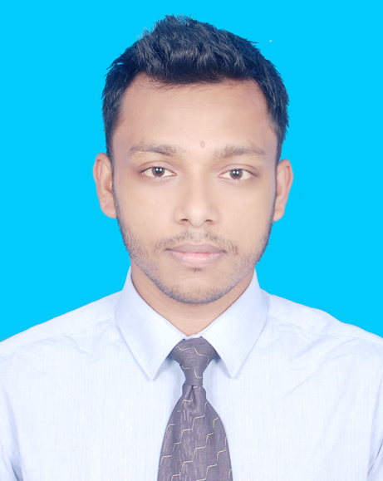
Contact Address:
Ghashitula Sobuj Sena Block- D House No- 43 Sylhet 3100.
Mobile No: 01751819181
email: mrmahtajsiu@gmail.com

CAREER OBJECTIVE
Searching for a desirable opportunity in which, I will have the scope of utilizing my skills and potentiality to do something innovative and challenging and from where I will be able to enhance my knowledge and efficiency and to add values to the institution.
EDUCATIONAL QUALIFICATIONS
Name of Exam. | Passing Year. | CGPA/GPA | Institution
MBA  Major in Marketing | 2018 | 3.90 Out of 4.00 | Leading University, Sylhet.
BBA (Hon’s)  Major in Marketing | 2017 | 3.59 Out of 4.00 | Sylhet International University, Sylhet.
HSC | 2012 | 4.40 out of 5.00 | Sylhet Government College.
SSC | 2010 | 4.94 out of 5.00 | Sylhet Govt. Pilot High School.

KEY QUALIFICATIONS
- Self-motivated, persistent and convincing power.
- Good at interpersonal and communication skill.
- Warm, friendly and have the ability to interact with people easily at all levels.
- Have better efficiency in Bangla and English
COMPUTER SKILLS
- MS Office: Word, Excel, PowerPoint and Internet.
INTEREST AND HOBBIES
- Personal Interest: Watching movies, Sports, Travelling and others.
PERSONAL INFORMATION
Name : Md Makshudur Rahman
Father’s Name : Md Kudrat Ullah
Mother’s Name : Mrs Ambiya Begum
Date of Birth : 27/10/1993
Permanent Address : Ghashitula Shobuj Sena Block- D House No- 43 Sylhet 3100.
Present Address : Ghashitula Shobuj Sena Block- D House No- 43 Sylhet 3100.
Nationality : Bangladeshi (By Birth)
Gender : Male
Marital Status : Unmarried
Religion : Islam
ReferenceS
Mr. Pranob Kumer Saha Mr. Md Mohsin Hossain
Assistant Professor Assistant Professor
Dept of Business Administration Dept of Business Administration
Sylhet International University Sylhet Sylhet International University Sylhet
Mobile: 01914706933 Mobile: 01715783583
Declaration
I do hereby, stating that all information mentioned above is absolutely correct with the best of knowledge.

Md Makshudur Rahman Date: 20th June, 2019

