Curriculum Vitae
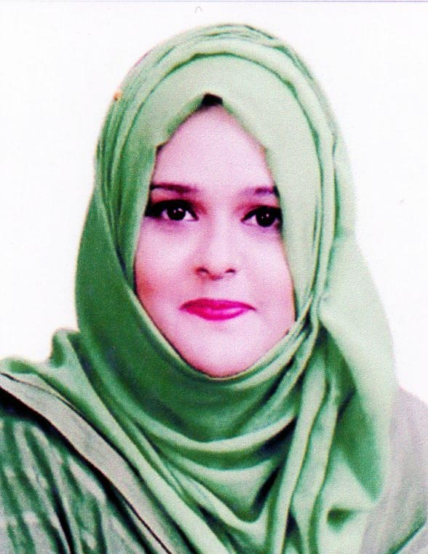
of
Khudeza Baksh Sadia

Cell: +88 01791515920
E-mail: Sadiabaksh1nonly@gmail.com

To establish myself as a government officer in a well-know organization where favorable environment and huge opportunities are given for building the career in the light of dynamism, honesty, enthusiasm, challenging & changing environment and occupying both the psychological & organizational position.

CAREER
OBJECTIVE

Name : Khudeza Baksh Sadia
Father’s Name : Late Rezuan Baksh Soudagor
Mother’s Name : Ruzi Baksh
Date of Birth : 6th November, 1993
Religion : Islam (By Faith)
Marital Status : Married
Blood Group : O (+ve)
Nationality : Bangladeshi (By Birth)
NID No : 5987227609
Permanent Address : House No. 29, Baksh Monjil, Jollarpar,
Zindabazar, Sylhet.

PERSONAL
DETAILS

- Good interpersonal skills.
- Capable to work under stress and take well-reasoned and timely decisions.
- Leadership and team building capacity.
- Able to work independently and within time frame.
- Enjoy working to meet challenge of quotes and other goal.
- Social Networking.

PERSONAL
STRENGTH

MS Word, MS Excel, MS Power Point, Internet browsing & E-mail etc.

COMPUTER
SKILL
]

Working
Experience

- Internee at Southeast Bank Limited, Laldighirpar Branch, Sylhet with effect from 1st September- 2018 to 30th November, 2018.
- I have been working as a Female Executive in London Tills Rolls Call Center at Eastern Plaza, Amberkhana, Sylhet from 1st December, 2018 to still now with fully satisfaction of higher authority.

Have an excellent command over English and Bengali language in reading, writing, Listening and Speaking.

LANGUAGE
PROFICIENCY

ACADEMIC
QUALIFCATION
Masters of Business Administration (M.B.A)
Institution : Metropolitan University, Sylhet
Department : Business Administration
Major Subject : Accounting and Information Systems
Result : 3rd Semester Running
Session : 2018 – 2019

Bachelor of Business Administration (B.B.A)
Institution : Metropolitan University, Sylhet
Department : Business Administration
Major Subject : Accounting and Information Systems
Result : CGPA-2.88 out of 4.00
Year of Pass : 2018

Higher Secondary Certificate (H.S.C)

Group : Humanities
Passing Year : 2013
Result : GPA- 4.10 out of 5.00
Board : Sylhet
Institute : Shahjalal Jamia Islamia School & College, Sylhet

Secondary School Certificate (S.S.C)

Group : Humanities
Passing Year : 2011
Result : GPA-3.69 out of 5.00
Board : Sylhet
Institute : Shahjalal Jamia Islamia School & College, Sylhet

- Mohammed Jamal Uddin
Head, Dept. of Business Administration
Metropolitan University, Sylhet
Mobil: 01558347255

- Mr. Md. Masud Rana
Assistant Professor, Dept. of Business Administration
Metropolitan University, Sylhet

Mobil: 01711069291

REFERENCE

I, the undersigned, certify that to the best of my knowledge and belief, these data correctly described my qualification, my experience and me. I undersigned that my willful misstatement described herein may lead to my disqualification or dismissal.

CERTIFICATION

-----------------------------------
Khudeza Baksh Sadia Date:

