Curriculum Vitae:  Md. Safianur Islam  M.B.A  Department of Accounting  Rajshahi college,Rajshahi  Mobile: 01770-012851  E-mail: mdsafianurislam@gmail.com | 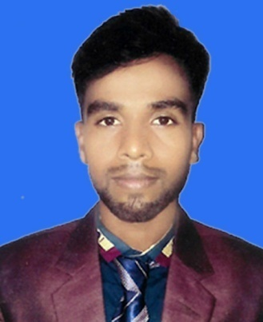

Professional Objective:
To obtained a standard job in any well-known organization where I can apply my creative skills and competency.

Academic Qualification:
Rajshahi College, Rajshahi (National University)  MBA in Accounting  CGPA- 3.06 in scale of 4.00 | 2016
Rajshahi College, Rajshahi (National University)  BBS in Accounting  GPA: Second class | 2014
Rajshahi City College, Rajshahi  H.S.C in Business studies  GPA: 4.10 in scale of 5.00 | 2011
Rajshahi Court Academy, Rajshahi  S.S.C in Business studies  GPA 4.06 in scale of 5.00 | 2009

IT Skill
# | Word processing & Presentation | : | Microsoft Word, Microsoft Power point.
# | Database & Spreadsheet | : | Microsoft Excel.
# | Internet Basics
# | Video Editing

Language Proficiency:
# Excellent Communication skill in English & Bangla both spoken and written.

Personal Information:

Name | : | Md. Safianur Islam
Father’s Name | : | Md. Rabiul Islam
Mother’s Name | : | Most. Rina Begum
Present Address | : | C/O. 1025, Vill. Laxmipurvatapara, P.O: G.P.O-6000, P.S: Rajpara, Dist: Rajshahi.
Permanent Address | : | C/O. 1025, Vill. Laxmipurvatapara, P.O: G.P.O-6000, P.S: Rajpara, Dist: Rajshahi.
Date of Barth | : | 1 May, 1993
Nationality | : | Bangladeshi
NID No | : | 101 935 1542
Gender | : | Male.
Marital status | : | Married
Religion | : | Islam
References:
Md. Nuruzzaman (Tuku)  B.Com(honours), L.L.B  Councilor word No-06  Rajshahi City Corporation  C/O: Laxmipurvatapara , H/N: 1071Rajpara, G.P.O-6000, Rajshahi  Contact No: 01717-515070  E-mail:mdnuruzzaman06@gmail.com | Md. Gholam Kalam Murshed  Officer  Sonali Bank Ltd, Rajshahi.  Greater road branch. G.P.O-6000, Rajpara, Rajshahi.  Contact No: 01737507884  E-mail: kajem2011@gmail.com

I do hereby declare that the above information is true and correct to the best of my knowledge in case of any false information; I shall be liable to appropriate legal.

Date:…………… (Md. Safianur Islam)

