Curriculum Vitae
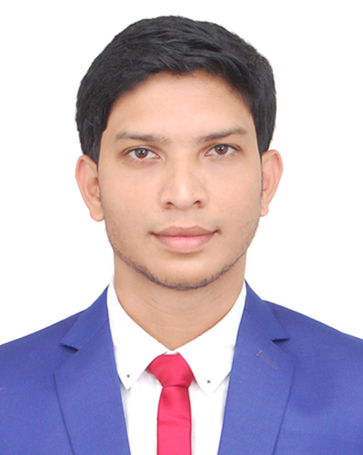
Of
Tanim Ahmed Chowdhury

Mailing Address:
Tanim Ahmed Chowdhury
Mina A Salam, House-133, Road-04, Block-E,
Shahjalal Uposhahor, Sylhet - 3100
Cell No. : +8801723 082 510
E-mail: tanim_tanil@yahoo.com

Career Objectives:
To pursue a highly rewarding career, seeking for a job in challenging and healthy work environment where I can utilize my skills and knowledge efficiently for organizational growth and I will have the opportunity to assert strong sense of responsibility to know about the real world laid ahead of me.

Educational Qualification:
Exam : B.Sc. in Computer Science & Engineering
Session : 2012 - 2016
Department : Computer Science & Engineering
Institution : Leading University, Sylhet
Result : 3.07(B) out of 4.00

Exam : Higher Secondary School Certificate (HSC)
Session : 2009 - 2010
Passing year : 2011
Group : Science
Result : A-
Institution : Jalalabad College, Subhanigat, Sylhet
Board : Sylhet

Exam : Secondary School Certificate (SSC)
Passing year : 2009
Group : Science
Result : A
Institution : Shahjalal Upashahor High School, Sylhet
Board : Sylhet

Training Courses:
- Basic Computer Course, from “Digitech Multimedia ” Uposhahor, Sylhet at 2009
- Web Developing.
- CCNA (SUST)

Workshops:
- Workshop on “How to increase the proficiency on English language ” Organized by British Council at Rose View Complex, Upashahar, Sylhet in 2014

Computer Skill:
Experienced in –Web Developing, WordPress.
Windows XP, Windows 7, Windows 8, Linux ubuntu, Office Applications ( MS Word, MS Excel, MS PowerPoint.)
Internet: Browsing & E – mail Literacy.

Job Experience:
Currently fresher, but enthusiastic to develop skills in the field.

Personal Information:
Father’s Name : Md. Abdul Mukit Chowdhury
Mother’s Name : Monoara Begum Chowdhury
Date of Birth : 10th August, 1992
Nationality : Bangladeshi
Religion : Islam
Blood Group : O+ (ve)
Present Address : Mina A Salam, House-133, Road-04, Block-E, Shahjalal Uposhahor, Sylhet - 3100
Permanent Address : Vill.- Monsurpur, P.O – Badedewrail , P.S- Zakiganj, Dist – Sylhet

Key Qualifications:
- A highly numerate with excellent communication skill.
- Analytical, Innovative, Self-motivating, Confident.
- “Can do” attitude and “Well Done” skill.
- Able to lead or to work as part of a team.
- Welcomes new challenges, especially if they involve implementing and developing schemes.

Co-Curricular Activities:
- Director of Documentation at “Leading University Model United Nations Association 2016”
- A founder and Working as a ‘Secretary at the “Mrinmoy”- A non-profit Organization.
- Managing Director at Talent Care Coaching Center (2011-2014), Shahjalal Uposhahor , Sylhet.
- Managing Director at Shikkhanir Coaching Center (2015-2016), Shahjalal Uposhahor , Sylhet.
- A member of United Nations Youth And Student Association Of Bangladesh(UNYSAB).

References:

Mr. Md. Asaduzzaman Khan Mr. Mahbub Ahmed
Assistant Professor & Head of Department Deputy General Manager
Department of CSE Pubali Bank Limited
Leading University, Sylhet. Dhaka Central Zone, Dhaka.
Cell Phone: +8801711003233 Cell Phone: +8801917704707
E-mail: head_cse@lus.ac.bd

Declaration:
I, the undersigned declare that the information specified in this Resume is true to the best of my belief and knowledge and correctly describes my experience and myself.

Signature

Tanim Ahmed Chowdhury

