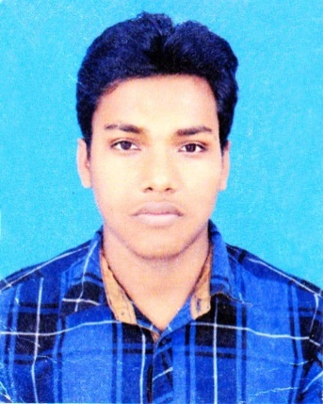
Atikur Rahman Razu
House no: 43/2 (2nd floor)
Shukrabad,Dhanmondi, Dhaka
Mobile: +8801763394691
Email:atikurdiu1993@gmail.com

Career Objective:
TO work creative marketing department any privet or public company or institution of Bangladesh and grow rapidly increasing responsibilities.
Education:
- 2017 : Running BBA 9th semester in Daffodil International University with (3.01) CGPA

- 2015 : Higher secondary school certificate Examination (HSC) from Naogaon govt. Collage under Rajshahi board With (3.92) grade.

- 2013 : Secondary school certificate Examination (SSC) from Naogaon govt. school under Rajshahi board with (3.92) grade.
Personal Qualification:
- Ability to easily assimilate new ideas concepts, methods and technologies, dedicated, innovative and self-motivated team player/ builder with work ethic.
- Strong oral communication, interpersonal, creative, Organizational, teaching and leadership skills, Excel in both independent and team work environments.
- I always try to learn something new
Training and workshop:
- Completed the day long workshop on “How to Become a sales Magnet”
- Workshop of “How you can achieve your dream”

Interpersonal Tariffs & Attitudes:
- Emotional Intelligence
- Team-Working, Groups And Meeting
- Negotiation skill
- Leadership skill
- Mentoring
- Conflict Resolution and Mediation skill
- Decision making and problem solving
Special Skills:
- Listening skill
- Martial-art,
- Hardworking
- Planning and communication ability,
- Sales skill
Experience:
- Currently working as a sales man of “Jannat travel agency” in Dhaka (04/04/2018-ongoing)
- Worked as a sales man of “Modina leather & polester film” in Dhaka for Nine month (01/10/2017 to 04/06/2018)
- worked as a sales man of “Boys Zone” in Naogaon for Six month.(01/05/2014 to 08/10/2014)

Language skills
- Mother tongue-Bengali
- Fluent in Bangla and fully work knowledge in English and Hindi.

Extra-curricular activities:
- Member of martial-art foundations
- Member of Badhon (Blood donner group)
- Work with a local charity
- Member of Manda youth club
- Boy Scouts from 2008-2012
Computer Skills
- Microsoft word
- Power point
- Spss
Interests area:
- Agriculture
- Traveling
- Martial-art
- Social networking
- Martial-art
PERSONAL INFORMATION:
Date of Birth : 12th June 1996
Gender : Male
Marital status : Single
Religion : Islam
Height : 5.5”
Blood group : O+
Nationality : Bangladeshi

