Curriculum vitae | 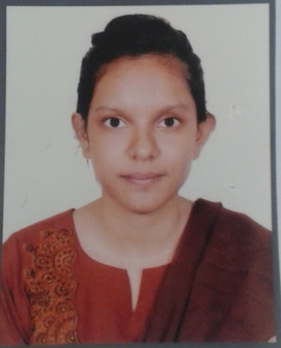

Sinthi Ahmed Afrin

Leading University,

Sylhet-3114, Bangladesh,

Contact: +8801726498309, +8801715240892

E-mail: a.sinthi@yahoo.com

Carrier Objective:
To face challenges using knowledge, perception and innovation to pursue long-term successful career in dynamic and professional environment of any reputed organization through my knowledge, aptitude, hard work, dedication and determination.

Academic Achievement:

Name of the Degree | Board/University | Passing Year | Obtained GPA/CGPA | Group/Subject Studied
BSS (Hons) | Leading University, SYlhet | 2018 | 2.71 (out of 4.00) | Computer Science & Engineering
HSC | M.C. Collage,  Sylhet Board | 2012 | 5.00 (out of 5.00) | Science
SSC | Shahjalal Jamea School &  Collage, Sylhet Board | 2010 | 5.00 (out of 5.00) | Science

Language Proficiency:

Bengali: Native

English: Good in speaking, writing & reading

Strength:
- Excellent interpersonal relationship ability, communication and presentation skills
- Very hard working and have the ability to work under pressure
- Able to learn quickly and to understand technical issues
- Self-driven, responsible, innovative, cooperative and team player
- Honest, trustworthy, self-motivated, energetic, adaptive to any environment

Skills:

Operating Systems : Windows 7, 10

Office Software : MS office (Word, Excel & Power point)

Internet : Browsing, E-mail and others communication skills
Course : LICT
Drawing Courses : Zilla Shilpokola Academy, Sylhet (1st division)

Co-Curricular Activities:
- Former Vice President & coordinator of “Social Club”
- General member of Band Community
- General member of Debating Club

Personal Details:

Name : Sinthi Ahmed Afrin
Father’s Name : Md. Salim Ahmed
Mother’s Name : Puspa Ahmed
Present Address : House No: 3, Road No: 5, Arambag tilagore road, Sylhet
Permanent Address : Village: Rajapur; P.O.:East Vadesshore; P.S.: Golapganj; Dist.: Sylhet
Date of Birth : 24th Octeber, 1993
Religion : Islam
Nationality : Bangladeshi (By Birth)
Sex : Female
Marital Status : Unmarried
References:
Harun-Al-Rashid(Dipu)
Chairman of Sylhet city center, Sylhet
Predident of Kushiara Lions club, Sylhet
Alpona 74, Shenpara,Shibgonj, Sylhet
Phone no: 01711333207

