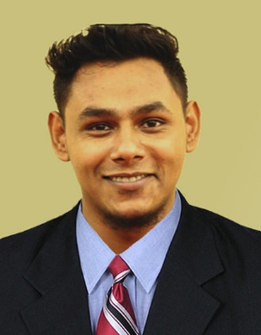
Curriculum vitae of
Sourav Bhattacharjee
347/11, North Bagbari, Sylhet
Contract: +8801637904659
Email ID: shuvo.vox60@gmail.com

Career Objective

To obtain a position that will enable me to use my strong organizational skills and ability to work well with people while contributing to the symbolic growth of the organization with my technical, innovative and logical skills.
Academic Snapshot

- BSS in Bangla (2017):
Department of Bangla Literature
Shahjalal University of Science and Technology, Sylhet.
Session: 2012-13
(Appeared)

- HSC (2012):
College: Jalalabad Cantonment Public School & College, Sylhet
Board: Sylhet
Group: Business Studies
Result: GPA 5.00 on a scale of 5.00

- SSC (2010):
School: Jalalabad Cantonment Public School & College, Sylhet
Board: Sylhet
Group: Business Studies
Result: GPA 5.00 on a scale of 5.00
Language

- Bangla : Native
- English : Fluent in speaking and listening as well as Reading and Writing.
IELTS SCORE: Overall – 7.0, ref no- BD001-175045-0280
Band Scores: Reading- 7.0, Listening- 7.5, Writing- 6.0, Listening- 7.5
- Spanish : Good in speaking and listening
Computer Skill

- Operating system : Windows XP/ 7/ 10
- Microsoft Office : Expert in Word, Power Point and Excel.
- Programming Language : C, C+
- Editing : Expert in audio and video editing using precise softwares
General Competence and Ability

- Have a good communication skill.
- Capable to work under pressure and meet targets.
- Have a quality for adopting new concepts of studies as well as responsibilities.
- Comfort to work as a team member.
- Ability to lead the team to gain desired goal
- Hardworking and conscious about time.

Co-Curriculum Activity
- Vocal and composer of H2SO4
- Vocal and guitarist of NONGAR (SUST) and SUGAR
- Band leader, Vocal and Guitarist of ONIRUDDHO
- Publication Secretary of Sylhet Divisional Band Association
- Organizing Secretary of Sylhet Musical Band Association
- General Secretary of Khola Janala (SUST)
- Former Treasurer of Reptilian Regiment, Sylhet
- Former Call Operator in Fusion BD Enterprise – You Compare Call Center
- Former marketing officer of Krittim Tech
- Operational chief of Trending Sylhet
- Former Field Supervisor of Nielsen BD
Achievements

- Got Scholarship at Talentpool in class 5
- Got Scholarship at Talentpool in class 8
- Got Scholarship at Primary in SSC examination,2010
- Got Scholarship at Tallentpool in HSC examination,2012
- Performed at Kolkata, Shilong (India) and at Nepal with H2SO4
- Champion at Inter Department Table-Tennis Tournament, SUST in 2014,2015
- 3rd Runner up at Inter Varsity Table-Tennis Tournament in 2016
Personal Information

Name: Sourav Bhattacharjee
Fathers Name: Shatadal Bhattacharjee
Mothers Name: Gouri Bhattacharjee
Date of Birth: 08/11/1995
Permanent Address: Debipur, Munshibazar, Kamalganj, Moulvibazar
Current Address: 347/11, North Bagbari, Sylhet

Nationality: Bangladeshi
Religion: Hindu
Contract No: +8801637904659
Reference

Sharadindu Bhattacharjee
Professor
Head of Dept. of Bangla Literature
Shahjalal University of Science and Technology (SUST).
Cell No. +8801731412679
E-mail: drsharadindu.bhattacharjee@gmail.com
Ms Farzana Siddika
Associate Professor
Dept. of Bangla Literature
Shahjalal University of Science and Technology (SUST).
Cell No. +8801731292222

E-mail: farzanasiddika@yahoo.com

I hereby declare that the details furnished above are true and correct to the best of my knowledge and belief and I undertake to inform you of any changes therein, immediately. In case any of information above is found untrue or misrepresenting. I am aware that I may be held liable for it.

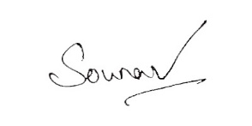
Sincerely

Sourav Bhattacharjee

Contact No. : +8801637904659

E-mail ID: shuvo.vox60@gmail.com

