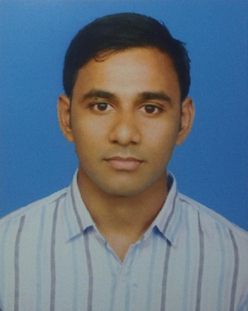
Curriculum vitae of

Anik Dash
78, R/A Nobabroad, Sheikhghat,
Sylhet Sador,Sylhet. Mobile :01737-602105
E-mail: anikdash1@gmail.com

CAREER OBJECTIVES:

Achieving a dynamic and challenging job in an organization where I can use my technical and interpersonal skills, creativity and above all my learning experience in order to develop my career and as well as to contribute in the welfare of the organization.
PERSONAL INFORMATION:

Name : Anik Dash
Father’s Name : Amar Chad Dash
Mother’s Name : Doly Talukdar
Mailing Address : 78,R/A Nobab Road Sheikhghat.
Sylhet Sador,Sylhet
E-mail Address : anikdash1@gmail.com
Permanent address : Village : Dhal P.O: Dhal Bazar
P.S: Derai Dist : Sunamgonj.
Contact Number : 01737-602105
Date of Birth : 18th September, 1994
Religion : Hindu
Nationality : Bangladeshi
Marital Status : Single

EDUCATIONAL BACKGROUND:

Degree | Board/University | Group/Major | Passing Year | Result
B.Sc.Engg. | Sylhet International University | CSE | 2018 | 3.53 out of 4
HSC | Sylhet | Science | 2013 | 4.10 out of 5
SSC | Sylhet | Science | 2011 | 5.00 out of 5

SKILLS:

- Operating System: Microsoft Windows , Windows XP Professional.
- Package Programs: Microsoft Office, Microsoft Excle, Microsoft PowerPoint, Microsoft Access.
- Programming Language: Fundamental knowledge on C Programming, Java, HTML ,CSS, Graphic Design, Web Development

LANGUAGE EFFICIENCY:

- Good ability in Writing & Reading and fluency in speaking both of Bengali & English language.

EXTRA CURRICULUM ACTIVITIES:

- Sports such as football and cricket.

OTHER PARTICIPATIONS
- Participate as a volunteer and work for poor people in flood affected area.
- Have a good hand in survey work.
- Involved in Jaago Foundation & Volunteer for Bangladesh.

SELF MOTIVATION & INNOVATION

- Innovative, dynamic and self-motivated.
- Ambitious and target oriented and confident.
- Have Leadership ability.
- Able to work individually and in a team.

INTERESTS

- Special interest in research works in the fields.
- Reading Journals, Magazines, Newspapers & Listening songs.
- To surf the Net and Traveling.

REFERENCES:
Anamika Talukder  Junior Officer  National Bank Limited  Subid Bazar Branch, Sylhet.  Mobile: 01772-595325 | Ajit Kumar Talukdar  Branch Manager  Agrani Bank Limited  Salutikor Bazar Branch, Sylhet.  Mobile: 01712-453388

I hereby declare that the information stated above is correct to the best of my knowledge.



…………………………………..
(Anik Dash)

