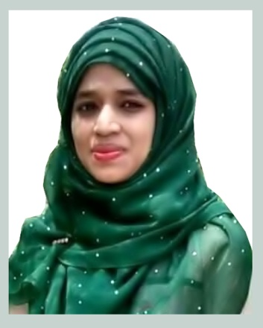
Resume of

Syeda Farjana Ayatul
Mobile: 01772-431629

Educational Qualification:
Career Objective:

Creative, energetic, people oriented, and resourceful individual seeking opportunity to work as a skilful professional in any organizational model where my educational background can be leveraged to augment organizational goals and objectives and enhance my professional experience.

- M.Sc Master’s in Botany
Institute : M. C College, Sylhet
University : National University
CGPA : 3.17
Year of passing : 2016

- B.Sc Hon’s in Botany
Institute : M. C College, Sylhet
University : National University
CGPA : 3.20
Year of passing : 2015

- Higher Secondary Certificate (H.S.C)
Institute : Sylhet Model School & College
Group : Science
Board : Sylhet
GPA : 3.80
Year of passing : 2011

- Secondary School Certificate (S.S.C)
Institute : Kishori Mohan Girls High School
Group : Science
Board : Sylhet
GPA : 4.19
Year of passing : 2009

ICT, Software Application, MS Office Internet Browsing, Downloading, Emailing,
Computer & Internet Skills:
Social Networking and all kind of works which is related by Internet.
Personal Strengths:

- Ability to work with people of multiple nationalities and culture.
- Good presentation skills
- Possess excellent writing and oral communication skills in English.
- Competent to work under pressure and demanding work environment.
- Efficient in co-ordinating teams effectively and is an enthusiastic team member.
- Skilled in analytical problem solving and is able to grasp new concept quickly.
- Self motivated to learn and to take responsibility.
Personal Information:

Name : Syeda Farjana Ayatul
Father’s Name : Moksud Ahmed
Mother’s Name : Parvin Begum
Present Address : Urmi-7, Sunapara, Shibganj, Sylhet
Permanent Address : AS above
Date of Birth : 25/10/1993
Nationality : Bangladeshi
Religion : Islam
Marital status : Unmarried
Experience:

- I have been working as a Assistant Teacher ( Science and Mathematics) in M.J AC School & College, Shibgonj, Sylhet from 1st January 2018 to 3rd December 2018.
- I have been working as a Assistant Teacher (Mathematics & English) in Genus Coaching Centre, at Zindabazar, Sylhet from 1st April 2015 to 30 August 2016.
Reference:

Muhammad Mukarrom Hussain
Manager
Medi-Vision Diagnostic &
Consultation Centre, Sylhet
Mobile: 01711-365625
E-mail: mukarrom1988@gmail.com
Musarraf Husen
Director
Genus Coaching Centre
Main Branch, Zindabazar, Sylhet
Mobile: 01716-836273
E-mail: musarrafhusen@gmail.com

Date: 27/07/19 Syeda Farjana Ayatul

