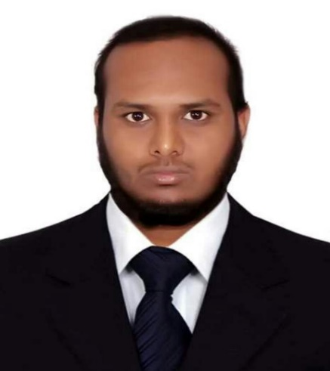
CURRICULAM VITAE
Name : A.S.A Wahid
Care of: Md. Azizur Rahman
Date of Birth: 24/12/1995
Nationality : Bangladeshi
National ID : 3742734613
Passport : BW0942444
Religion: Islam
Address : Keshabpur, Gopalpur, Lalpur, Natore.
Contact : 01626177041
E-mail : shaid.wahid@gmail.com
Looking for a job where I can find the scope to utilize my potentiality, adaptability and skill to do something innovative and from where I will be able to enhance my career.

Education and qualifications:
Current studies:
January 2016 to April 2020 BSC in Computer Science and Engineering
Sonargaon University
CGPA : 3:50 out of 4
Higher Education:
June 2011 to June 2015 Science
Gopalpur College, Lalpur, Natore, Post code: 6420
GPA: 3.30 out of 5
Secondary Education:
January 2009 to March 2011 Computer & Information Technology
Chaknazirpur Vocational And Business Management Institute, Natore, Post code: 6420
GPA: 4.19 out of 5

Other skills and achievements:
Fluent in English (Second language), Software(Microsoft office, Adobe Producte and Internet browsing).

Hobby: Guitar player, Story reader, Travel.

References: available on request

