Tanvir Ahmed 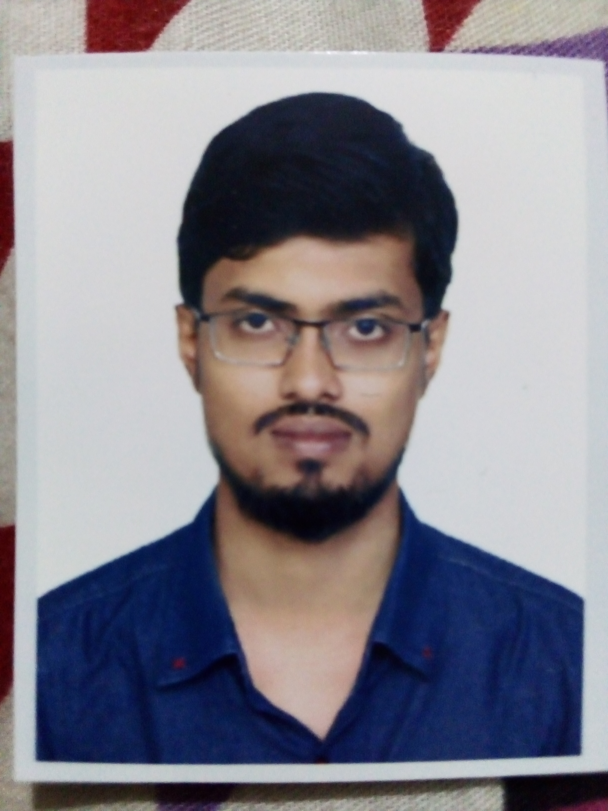
House No. 123,Mohona
Parkview R/A, Pathantula, Sylhet.
Email: tanveerahmed13228@gmail.com
Phone: 01913990215
Career Objective:
To work hard with full determination and dedication to achieve organizational as well as personal goals.

Educational Background:
Bachelor of Science (B.Sc.):
Discipline : Mathematics
Session : 2015-16
CGPA : 3.5 (Ongoing)

Higher Secondary Certificate (H.S.C.)
Board : Sylhet
Institute : M.C. College, Sylhet
Group : Science
Result : GPA 5.00
Passing Year : 2014

Secondary School Certificate (S.S.C.):
Board : Sylhet
Institute : Border Guard Public School and College
Group : Science
Result : GPA 5.00
Passing Year : 2012

Personal Information:
Father's Name : Md. Hurmat Ali
Mother's Name : Mst. Jamirun Nesa
Date of Birth : 1995-05-12
Gender : Male
Religion : Islam
Permanent Address : Vill. Jalalpur, P.O. Duara Bazar
P.S. Duara Bazar District. Sunamgonj
Nationality : Bangladeshi
Marital Status : Married

