CURRICULUM VITAE
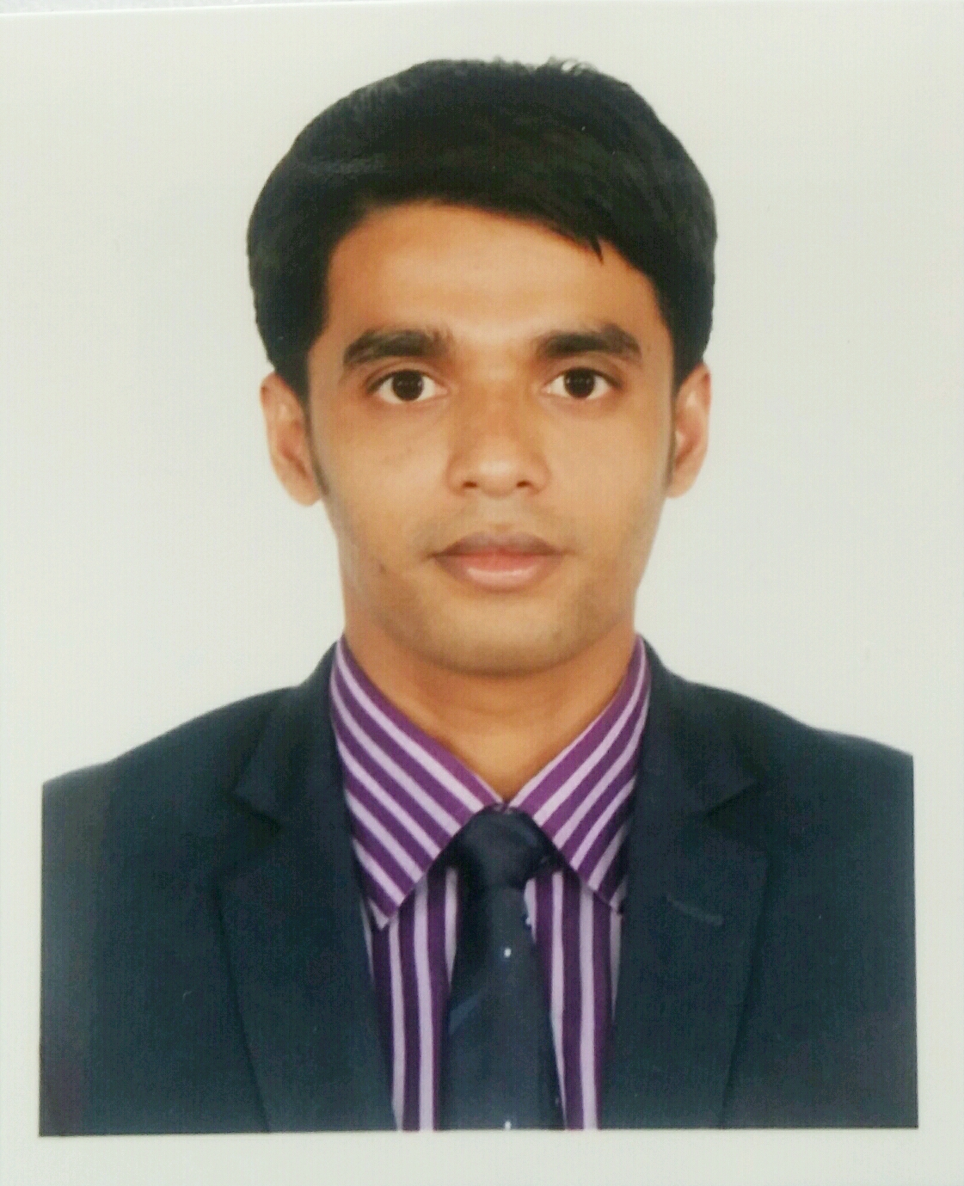
Moinul Islam
Mailing Address : Nir Nirjon,457/1, Ashkuna, Medical road, Dakshin Khan, Dhaka.
Cell: +88001795398267
E-mail: moinulislam93@yahoo.com

Career Objective
I would like to establish myself as a successful professional with full dedication to the organization.

Educational Pursuits

E.M.B.A Jagannath University, Dhaka
Department of Accounting & Information System
Appeared (2 Year)
B.B.A Sylhet International University, Sylhet
2012-2016, Department of Business Administration Major in Finance & Banking CGPA- 3.34 on 4-point scale
H.S.C Madan Mohon College, Sylhet
2011, Business Studies, Sylhet Board
GPA- 3.90 on 5-point scale
S.S.C Dungria High School
2009, Science, Sylhet Board
GPA- 4.06 on 5-point scale
Professional Qualification
- Certificate Course in Computer Application.
Course Name : Diploma in Computer Science & Engineering
Course Duration : 6 months.
Name of Institution : National Youth Development and Training Center (NYDTC) TRAINING SUMMARY
- Certificate on Mastering Customer Service in Impel Service & Solutions (ISSL). Supported by Skills for Employment Investment Program (SEIP), Finance Division, Ministry of Finance,Bangladesh.
- Certificate on Speaking Fluency with the British Council, Bangladesh.
- Internship in Southeast Bank Limited (3 months).
PERSONAL INTEREST
Love to Internet browsing, social networking. Reading Books & online newspaper and learning English.
Computer Skills

Operating System: Windows (98, 2000, XP, 7, 8, 10)
Application Software: Microsoft Office (Word, Excel, Power Point) and Others.
general competency and ability

      - Proficiency in speaking and writing both English and Bengali languages.
      - Good inter personal, communication and presentation skills.
- Capability of working as a team member and influence others.

Personal Details

Name : Moinul Islam
Father’s Name : Md. Amir Uddin
Mother’s Name : Jahanara Begum
Permanent address :Muhona D-23,Kucherpara,Brammonshashon,Sylhet.
Present Address : Nir Nirjon, 457/1 Ashkuna, Medical Road, Dakshinkhan, Dhaka.
Date of Birth : 5th November, 1993.
National ID : 3743349189
Blood Group : O+
Nationality : Bangladeshi

I do hereby ensure that the all information above is authentic.
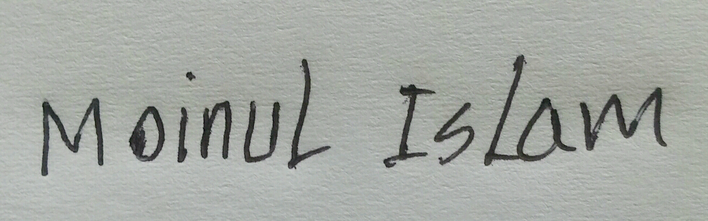

......................................
(Moinul Islam)

