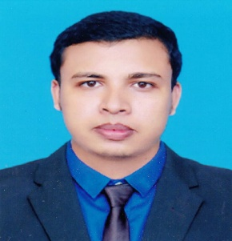
CURRICULUM VITAE
OF

MD. KAMRUL HASAN SHUVO

Address : 88/12, Sagordiggirpar, Sylhet
Email : kamrulhasanshuvo6432@gmail.com
Cell : +8801761218183

CAREER OBJECTIVE:
A young, dynamic person seeking challenging position in the field of professional world where I can learn and grow my skills.
ACADEMIC QUALIFICATION:
Bachelor of Business Administration:
Institute : Metropolitan University, Sylhet
Major : Accounting & Information System
Result : CGPA 3.41 (Scale-4)
Passing Year : 2018
Higher Secondary Certificate:
Institute : Blue Bird School & College, Sylhet
Group : Business Study
Result : GPA 4.60 (Scale-5)
Passing Year : 2013
Secondary School Certificate:
Institute : Hatia High School
Group : Science
Result : GPA 3.88 (Scale-5)
Passing Year : 2011
COMPUTER SKILLS:
- Office Application: MS Word, MS Excel, MS Power Point, MS Access.
- Internet Browsing.

LANGUAGE PROFICIENCY:
- Bengali Mother Tongue.
- English- Fluent both in speaking and writing.
INTEREST:
Playing cricket, football, watching movie, traveling, enjoying music and making fun.
PERSONAL DETAILS:
Name : Md. Kamrul Hasan Shuvo
Father’s Name : Md. Jahid Hossen
Mother’s Name : Mst. Sulekha Begum
Date of Birth : August 18, 1995
Nationality : Bangladeshi
Religion : Islam
Permanent Address : Vill: Haita, P.O: Hatia, P.S: Derai, Dist: Sunamgonj
Marital Status : Single
Blood Group : O⁺

PERSONAL ATTRIBUTIES:
- Ability to easily assimilate new ideas, concepts, methods and technologies and adaptability in every changing environment.
- Believe me as an enthusiastic learner and have the utmost curiosity to confront challenges and learn from them with temptation
REFERENCES:
1. Prof. Dr. Taher Billal Khalifa 2. Md. Jamal Uddin
Dean, School of Business Assistant Professor & Head In charge
Metropolitan University, Sylhet Department of Business Administration
Contact NO: 01711-969525 Metropolitan University, Sylhet
Contact NO: 01558347255
DECLARATION:
I am certifying that this CV correctly describes my biography, education and all other relevant information.
.......................................................
Md. Kamrul Hasan Shuvo

