CURRICULUM VITAE
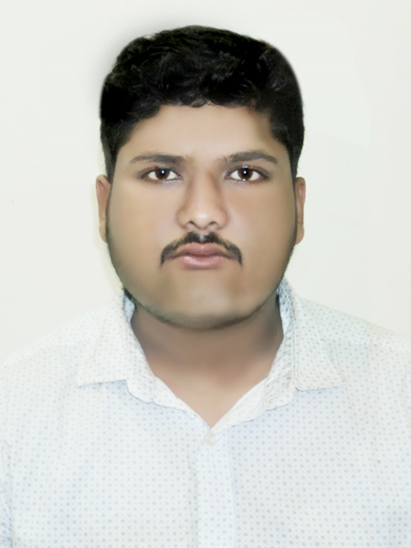
OF
DEBADIP DAS PRITAM
Mailing Address: Abdul Hannan Road, Khulsi Colony, Chottogram.
Mobile: 01623-613782.
E-mail: ddpritam36@gmail.com

Career Objectives

A challenging career in a dynamic organization where there is an opportunity that provides an excellent job environment for career growth and practice a professional performance culture where the quality performance of talent and creativity is recognized and rewarded as well as to utilize my knowledge for professional career development.
Personal Information
Father’s Name : Samar Das.
Mother’s Name : Puspa Das.
Permanent Address : Vill-Durgapur, P.O- Susang-2420,
P.S- Durgapur, Dis-Netrokona.
Present Address : Abdul Hannan Road, Khulsi Colony, Nasirabad, Chittagong.
Date of Birth : 07/02/1995.
Religion : Hindu.
Sex : Male.
Marital status : Single.
Nationality : Bangladeshi (By Birth).
National ID Number : 19957221803000015.

Educational Qualification
Hon’s in Microbiology:
Institution : Prime Asia University
Session : 2014-15
Passing year : 2018
Page 1 of 2

(02)

Diploma in MATS :
Passing Year : 2013.
Institution : RUMDO Medical Assistant School.
Board : The State Medical Faculty of Bangladesh.

Secondary School Certificate (S.S.C)
Group : Science.
Result : GPA-4.31.
Year : 2010
Institution : M.K.C.M Pilot Govt. High School.
Board : Dhaka.

Languages Skill:
- Fluent in Bengali and English.

Experience
I have been working as a Sales Executive in Article Mymensingh.
I have been working as a Customer Care Officer in Robi Axiata Ltd.
I have been still working as a Sales Executive in Asian Mobile.

Extra Curricular Activities
1 year Experience in working on Computer Office Application.
Playing Football & Cricket, Fishing in river, Bike Driving.

I certify that the statements made above are correct.

Signature
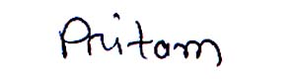
(Debadip Das Pritam)
Date :

