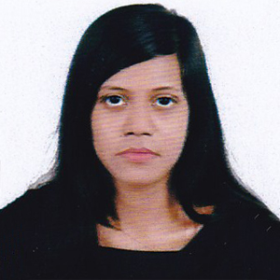
Carriculum Vitae

Mst Ruhina Begum

Kazi Iliyas, Zindabazar

Sylhet- 3100

Mobile: 01778185280

E-mail:Ruhina40@gmail.com

Career Objective:
To pursue a highly rewarding career, seeking for a job in challenging and healthy work environment where I can utilize my skills and knowledge efficiently for organizational growth.

Personal Details:
Name : Mst. Ruhina Begum
Father’s Name : Shah Md Babul Miah
Mother’s Name : Nehar Begum
Date of Birth : 10-11-1994
Nationality : Bangladeshi
Blood Group : B+
Marital Status : Unmarried
Permanent address : Vill.Chor Muhammad Pur( Fakir Para)
: P.O: Birahim Pur, P.S.Mugla Bazar, District. Sylhet

Educational Background:
Degree : Bachelor of Business Administration
Result : CGPA: 3.06
Institution : Leading University
Major Subject : Accounting Information System (AIS)
Passing Year : 2016

Degree : HSC
Result : GPA: 4.80
Institution : Noorjahan Memorial Women’s Degree College, Sylhet
Board : Sylhet
Group : Business study
Passing Year : 2012

Degree : SSC
Result : GPA: 4.38
Institution : Nobarun High School, South Surma, Sylhet
Board : Sylhet
Group : Humanities
Passing Year : 2010
Internship Training:
Three MonthsExperience training in “National Bank Limited”.

Membership:
Member of Leading University Social Service Club
Member of Orpheus a musical club in Leading University

Language Proficiency:
Bengali: Excellent in speaking, reading and writing
English: Excellent in speaking, reading and writing

Computer Skills:
MS. Office, Word, Excel, Power Point & Internet Browsing
Training:
National Help desk Call Center Agent Training
Interest:
Reading novel and Humorous Story, Traveling, Watching Movies, Enjoying Music and Sports
Strength:
Hard working
Self-motivated, Enthusiastic and Punctual
Dynamic and creative in thinking
Sense of good organizational behaviour

References:
- Ihit Sharma
Senior Lecturer (AIS)
Leading University, Sylhet
Contact No.01819848464
Signature

....................................
(Mst Ruhina Begum)
Date:

