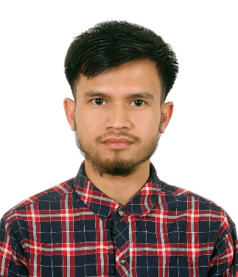
Drikson Manar
Junior Networking Engineer
Email: driksonmanar548@gmail.com
Mob.No : +8801317-259726
Present Adress:
Kathal Bagan, Green Road, Dhaka
Permanent Adress:
Jhimai pan punji. PO: Kulaura, Upazila: Kulaura,District: Moulvibazar.

CAREER OBJECTIVE
To secure a position and be a part of progressive organization that gives scope to enhance my knowledge and skills, which can be used for the organizational growth and personal growth and contribute to the organization success.
PROFESSIONAL TRAINING

- Completed Cisco CCNA Routing and Switching Training from Creative IT Institute,Dhaka.
- Completed CompTia A+, Cyber Security Training from Creative IT Institute, Dhaka.
TECHNICAL SKILLS
Hardware and Maintenance:
- Installing and configuring the peripherals, components and drivers.
- Installing and configuring Windows 7, 8 and Windows 10.
- Hardware troubleshooting .
NETWORKING CCNA:
- IP Addressing, IP Troubleshooting, Routing, Switching, VLANs, CIDR, Cabling, VTP, STP.
- Routing Static routing, RIP V1 & V2, OSPF, EIGRP and BGP.
- Remote administration tools: Telnet and SSH.
- Basic knowledge on MPLS, IPSec, HSRP and VRRP.
- Firewalls: CISCO ASA, CISCO PIX, Fortinet Checkpoint etc.
- Network Technology: CDP, Access control list (ACL), NAT and PAT, GRE tunneling, DHCP.
- Router Basic configuration of Router 1800, 2600, 2800, and 2900 series.
- Switch: Basic configuration on Cisco switches 1600, 2900 and 2950 series.

EDUCATION QUALIFICATION

INSTITUTION | EXAM | BOARD | GPA | PASSING YEAR
IslamiBank Institute of technology | Diploma in Engineering | BTEB |  | 2020
Kashinath Alauddin High school & College | SSC | Sylhet | 3.56 | 2012
Upadhaya Abdus Sohid College | HSC | Sylhet | 2.83 | 2014

LANGUAGE PROFICIENCY

Confident Enough to Communication Both in Bengali and English.

PERSONAL PROFILE

Name : Drikson Manar
Father’s Name : Late Ram Rupusi
Mather’s Name : Warin Manar
Date of Birth : 14-04-1996
NID No : 8685844022
Height : 5.1”
Blood Group : AB+
Weight : 50 kg
Religion : Christian
Maritial Status : Unmarried
Nationality : Bangladeshi

