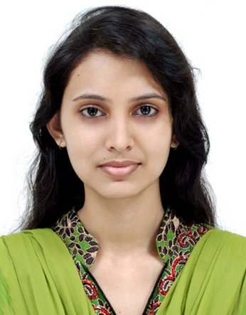
Curriculum Vitae
Of
Thakmina Sermon Diana
Email:- sermondianark@gmail.com
Mobile:- 01741871562
I am Believe in work. And searching for a desirable opportunity to prove my creative sense.

Career Objective

Academic Qualification
Masters Of Social Science (M.S.S) in Sociology

Institution : M.C. College (Under The National University ), Sylhet.
Session : 2015-16
Result : 2.69

Bachelor Of Social Science (B.S.S) in Sociology

Institution : M.C. College (Under The National University ), Sylhet.
Session : 2011-12
Result : 2.93

Secondery School Certificate (S.S.C)

Institution : Al- Amin Jamia Islamia Secondary High School
Session : 2007-08
Group : Science
Result : GPA- 4.25
Passing Year : 2009
Board : Sylhet

- One year’s course in “Post Graduate Diploma in Computer (MS Office, Hardware, Graphics Design)” from NYDTC.
- Six Months Diploma in “Information and Communication Technology” from BCC.
- Four Months Diploma in “Graphics Design” from TTC.

Computer Skill

Working Experience
- I worked in a Consultancy farm (ACTEP Global Touch) as a Counselor and Accountant from September 2012 to February 2014..
- I worked in a IT farm (Virtual Edge) as a Office and Customer Care Executive from March to Jun 2017.
- I worked in a Japan’s Brand (Miniso) as a Accountant from July 2017 to January 2018.
- I worked in Banoful as a Cash Officer from February to July 2018.
- I am worked in Walton as a Sales Executive from February to April 2019.

A drive to perform, patience, accepting challenging work, create something new and willingness to learn..
Esteem Trains

Academic Qualification
Higher Secondary Certificate (H.S.C)

Institution : Jalalabad College
Session : 2009-10
Group : Science
Result : GPA- 3.40
Passing Year : 2011
Board : Sylhet

Secondary School Certificate (S.S.C)

Institution : Al- Amin Jamia Islamia Secondary High School
Session : 2007-08
Group : Science
Result : GPA- 4.25
Passing Year : 2009
Board : Sylhet

Language Proficiency
I have good command in both Bangla and English oral and writing..

Interest
- Create Something Exotic
- Achieve Knowledge
- Fashion
- Taking Ricks

Personal Information
Name : Thakmina Sermon Diana
Father’s Name : Shafik Miah
Mother’s Name : Minara Begum
Date Of Birth : 01.08.1994
Sex : Female
Religion : Islam
Marital Status : Unmarried
Nationality : Bangladeshi
Address : Road No-03, House No- 45, Diganta A/P, Khadim Nagar, Sylhet..

Reference
Relation : Uncle
Name : Abdul Hamid
Address : House No- 09, Road No- 21,
Block – B, Shahjalal Upusohor,
Sylhet, Bangladesh
Profession : SI (Police)
Mobile No : 01715-274412

Signature

(Thakmina Sermon Diana)

Date:

