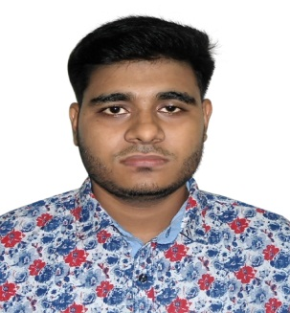
CRRICULAM VITAE
OF
MD: SHAKIL HUSSAIN

- Personal Information
Name | : Md: Shakil Hussain
Father’s Name | : Md: Abdul Rashid
Mother’s Name | : Champa Begum
Permanent Address | : Musargown,South Surma,25  No Word,Sylhet City Corportion
Present Address | : Do
Date Of Birth | : 25 June 1996
Religion | : Islam
Nationnality | : Bangladesh
Marital Status | : Unmarried
Mobile Number | : 01741585438

- Educational Qualification
Name Of Exam | Group | Passing Year | Result | Board
PSC | - | 2007 | 3.33 | Sylhet
JSC | - | 2010 | 1.86 | Sylhet
SSC | Humanities | 2014 | 3.06 | Sylhet

- Computer Experience
- Bangla Tayping
- English Tayping
- Microsoft Office Word
- Microsoft Office Excel
- Microsoft Office Power Point
- Microsoft office Access
Date:- 30/04/2019
Shakil
____________________
(Signature)

