Dipu Ahmed
Address: Raykhail, Jalalpur, Moglabazar, Sylhet
Mobile : 01776-757668
E-mail : chyshahid13@gmail.com
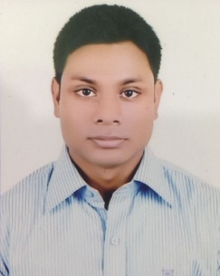
Career Objective:

Seeking a challenging career with progressive organization offering prospect to demonstrate and argument my skill, where seemliness of work provides job satisfaction and the place of work provide potential avenues for learning and growing.

Career Summary:

- Good customer focuses approach.
- Good interpersonal negotiation skills.
- Capable of doing work with tight deadline.
- Strong Communication Skill (Presentation, Public speaking etc.)
- Good team worker.
- Can work creative, self-initiative skills.
- Strong analytical ability.

Academic qualification:

Bachelor of Business Administration (BBA)
Year: 2015
CGPA: 2.86 in scale of 4
Major in Accounting.
Madan Mohan College, Sylhet

Higher Secondary Certificate (HSC)
Year: 2011
GPA 3.90 in scale of 5.00
Group: Science
Scholarshome, Sylhet

Secondary School Certificate (SSC)
Year: 2008
GPA 3.75 in scale of 5.00
Group: Science
The Aided High School, Sylhet

LANGUAGE SKILLS
Have good command over Bengali and English both oral and written.

COMPUTER SKILLS
Application Software - MS Office Package Program (MS Word, MS Power point, MS Excel.) familiar with the use of e-mail as well as internet browsing.

PERSONAL INFORMATION
Father's Name | : | Tomjid Miah
Mother's Name | : | Rohima Begum
Date of Birth | : | July 12, 1992
Gender | : | Male
Marital Status | : | Unmarried
Nationality | : | Bangladeshi
National Id No. | : | 19929113137000056
Religion | : | Islam
Permanent Address | : | Raykhail, Jalalpur, Moglabazar, Sylhet

Reference:
Md. Anamul Kabir Tamim  Executive officer & fex. In Charge  Sylhet Branch  Social Islami Bank Limited  Mobile – 01717-793992,01779-796935 | Mohammed Sharif Ahmed  Lecturer in Accounting  Department of Business Administration  Madan Mohan College, Sylhet  Mobile – 01712-891759
I do hereby declare that particulars provided above are true and no misinformation is given.

Yours Truly

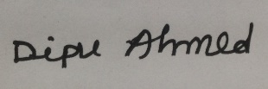
…………………………...
Dipu Ahmed

