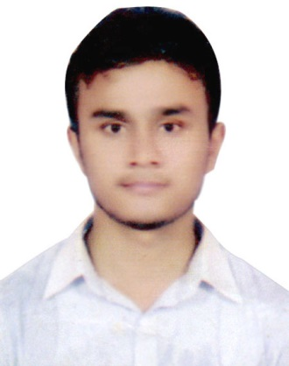
Resume
Of
Dr. Mohammad Nazmul Amin Faisal

Mailing Address:

Mailing Address - C/O: Munsur Alir Bari, vill: Kachiapar P.O: T.M. Bazar, P.S : Sandwip, Chattogram -4300

Mobile: 01814-321937, 01740-232082

E-mail:

