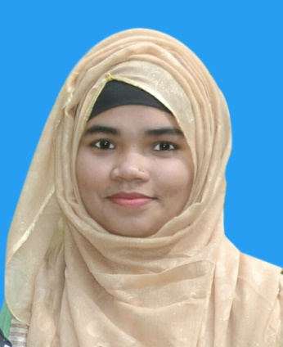

PROFESSIONAL EXPERIENCE

Internship
National Credit and Commerce Bank pvt Ltd. (Juri Branch)
30 September 2017 – 30 November 2017
- Prepared an Internship report on SME Banking of NCC Bank.
- Worked in a corporate environment & interacted with employees from different hierarchies in a professional environment.
- Worked in customer service department and also able to open 100 customers bank account (current and saving), 40 SSS account, 30 FDR and prepared at least 30 pay order during my internship.
- Worked in Foreign Remittance Department, usually served approximately 80 clients for remittance service in daily basis and posting these data in RMS.
- Also providing utilities services to the customer and data entry of those utilities bill.
- Successfully I achieved all the targets given by Bank Manager during my internship.

EDUCATION

Bachelors in Business Administration (BBA), Major in Finance & Banking
Metropolitan University; Bangladesh
Spring 2015- Fall 2018
Secured 3.96 out of 4.00

Higher secondary certificate (HSC), Major in Business Study
T. N. K. Academy degree Collage
Batch 2013
Secured5.00 out of 5.00

Secondary School Certificate (SSC), Major in Business Study
Juri Model High School
Batch 2011
Secured 5.00 out of 5.00

Majeda Jannat Ami

MolviBazar, Sylhet
Email: majedaemi@gmail.com
Mobile 01772971488

CAREER OBJECTIVE
As a Fresh Graduate I am highly interested to be a part of a well-established company through hard work, creativity, honesty and sincerity and finally want to be an asset in my desired position by applying my academic excellences and experiences.

CORE COMPETENCIES
- Ambitious, Hardworking and excellent in time management.
- Great teamwork and Leadership skill.
- Able to work logically, analyze solution and come up with solution.
- Self-motivated and Confident.
- Able to work in different environment.
- Excellent Interpersonal Communication skill.

REFERENCES
- Md. Ziaur Rahman
NCC Bank Limited
Manager
Juri Branch, Moulvibazar
Contact No: +880 1716870323

- Professor Dr. Taher Billal Khalifa
Department of Business Administration
Dean
Metropolitan University, Sylhet
E-mail: tkhalifa@metrouni.edu.bd

COMPUTER SKILLS
- Microsoft Excel, Word, Power point, Browsing and Outlook

SOFT SKILLS
- Self Confident
- Well Organized
- Teamwork
- Effective Time management
- Possess good interpersonal, oral and writing skills.
- Strong communicate skills
- Problem Solving
- Independent
- Knows English & Bangla

PERSONAL INFORMATION
- Date of Birth: December 11, 1996
- Nationality: Bangladeshi
- Father's name: Md. Moin Uddin
- Mother's name: Mst. Sultana Akther
- Present Address: Amtoil, Juri, Moulvibazar, Sylhet

