Curriculum Vitae

OF

MD. EMON ALI

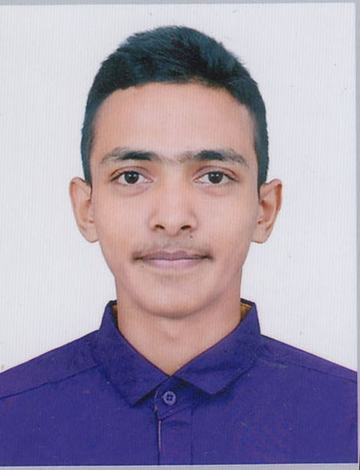

Torongo 4/18, Soyod Mugni,Khasdobir, Sylhet-3100.
Mobile: 01635068932/01999702131
E-mail:mdemonchowdhury@yahoo.com
Rcyemon2015@gmail.com

Career Objective
Seeking for a job to pursue a highly rewarding career and healthy work environment where I can utilize my skill and knowledge efficiently for the organizational growth.
Graduation (BA)

Education Qualification :
Institute : M C College, Sylhet
University : National University.
Result : Study On Bachelor Degree 1st year

Higher Secondary Certificate H.S.C
Institution name Shah Khurrom Degree College. Sylhet.
Passing year 2016-17
Board Sylhet
Trade Science
Result: GPA-2.83

Secondary School Certificate S.S.C
Institution name The AidedHigh School, Sylhet.
Passing year 2014-15
Board Sylhet
Trade Science
Result: GPA-3.72
Computer skills Offices Application & Adobe Photoshop & Data Anti,File Scan.
Personal skills and competency

Job experience * Sales Assistant Jast Discount Shop In 1st October-2016 to 1st March.
*Asst. Manager & Sales Representative Mobility Itap’n Pay in 2nd
March 2017 to December 2017, (Magna Bank Mobile Banking)
*Manager Kabab Cafe Restaurant, Dorga Gate, sylhet.(6 Month)
*Manager & Cordinator,Mass Marketing Of Corporate Mobility Itap’n pay in 1st January 2018 – Work On((Magna Bank Mobile Banking)
* Sales Representative Happy Time Food Co. Ltd In 1st March –Word On.
Social skill and competences:
1. National ID Card Camping City Comparison & Union Parishad.
2.Tall Twister at Leo Club of Sylhet (2018-19)
3.Volunteer at Bangladesh Red Crescent Youth, Sylhet Unit.
4.Vice President Interact Club of Sylhet Surma (2018-19)
5.Scout Member at The Aided High School,Scout Group ,Sylhet.
6. Officer at Fresh Distribution House Stock Audit-2019

Training Participated

Name :Md. Emon Ali
Nick Name :Emon
Fathers Name :Md. Esak Ali
Mothers Name :Helon Bibi
Nationality :Bangladeshi
Date of birth :05 January 2000
Gender :Male
Marital status :Unmarried
Religion :Islam
Address :Torongo 4/18 Soyod Mugni Khasdobir,Sylhet P.O.-Sylhet, P.S.Sodor. :Dist.-Sylhet, Bangladesh.
Mobile no :+8801635068932/01999702131
Blood group :O+ve
E-mail :mdemonchowdhury@yahoo.com
National ID : N/A
Birth Cerificate :20009195006006830

Language Skills
Bangla : Excellent in Reading, Writing and Speaking Bengali fluently
(Mother Language).

Interests
Traveling in various historical and attractive places, friendship & hearing song.
Program and Duty Performed
1. Worked as a medical team member Bishwa Zonal Ijjtema 2016
2. In BANGABANDHU Gold Cup 2015 football match worked as a medical team
Member.
3. Worked as a volunteer at International Sylhet Festival 2017.
4. Worked as a medical team member in ICC UNDER-19 Cricket World Cup Bangladesh 2016
1. RC/RC Basic & First Aid Training Conducted by Red Crescent Youth, Sylhet Unit

Training Participated
on 2015.

Reference

1.Md. Imran Ali 2. MUFTI ABDUL MOKSHIT AL- MALUM
Family Member (Brother) Authorized M&F Agro & Food (Mobility I Tap Pay)
Contact No. 01782575102/01917529189 Contact No.01711366126

Date: (Signature)

