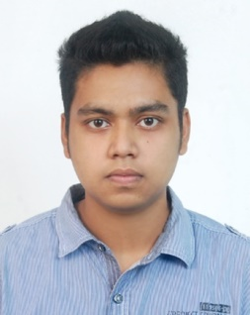
FAHIM SHAHRIYAR
+880-1712-154903
fahimshahriyarbs500as@gmail.com
Personal Info.
Age: 22
Date of Birth : 10 March 1997
Present Address: House# 09, Road# 20, Block# B, Uposhahor, Sylhet
Permanent Address: As Above
Education:
J.S.C : GPA 5.0 (2010, Bangladesh Bank School) Sylhet Board
S.S.C : GPA 5.0 (2013, Bangladesh Bank School) Sylhet Board
H.S.C : GPA 4.89 (2015, M.C College, Sylhet) Sylhet Board
B.Sc. Honors: Sub- Mathematics, (Session-2015-16, M.C College, Sylhet)
National University Of Bangladesh
1st year : CGPA 3.17
2nd year : CGPA 3.33
3rd year : CGPA 3.69
4th year : Running
Diploma In Computer from Bangladesh Computer Council, Sylhet
Work Experience: Supervisor at AAS, Sylhet (event management) (2017-19)
Skills :
- Computer Fundamentals & Office Automation
- Google Sheet
- Programming with C
- Web Design & Development
- Graphics
- Hardware Maintenance & Troubleshooting

Interests :
- Computer Science
- Mathematics
- Driving
- Football

