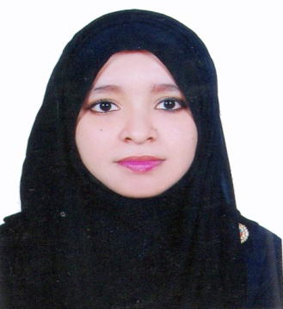
CURRICULUM VITAE
OF
FARHANA PARVIN
Contact Address:
Sebok- 68, Raynagar
Mirabazar, Sylhet- 3100.
Cell: +88 01704-406761
Email: farhana.bba31@gmail.com

Objective
Objective Career

To obtain a responsible position through which I can utilize my knowledge, enhance my skills as well as can acquire the ability to face a high level of challenges, and get myself provided with varied experience and at the same time I would like to contribute by best to the organization.

Educational Qualifications

Master of Business Administration (MBA):
Institution : Metropolitan University, Sylhet.
Session : 2018-2019
Passing Year : 2019 (Running Semester 5th)
Major : Finance & Banking
Result : CGPA- 3.53 (Out of 4.00)

Bachelor of Business Administration (BBA):
Institution : Metropolitan University, Sylhet.
Session : 2013-2017
Passing Year : 2017
Major : Finance & Banking
Result : CGPA- 3.56 (Out of 4.00)

Higher Secondary Certificate (H.S.C):
Institution : SAARC International College Bangladesh, Sylhet.
Passing Year : 2013
Result : GPA- 4.30 (Out of 5.00)
Group : Business Studies
Board : Sylhet.

Secondary School Certificate (S.S.C):
Institution : Syed Hatim Ali High School, Sylhet.
Passing Year : 2011
Result : GPA- 3.56 (Out of 5.00)
Group : Humanities
Board : Sylhet.

Computer Knowledge

- Able to prepare any type of documents with MS word & Excel
- Able to prepare any type of slide with MS PowerPoint
- Having knowledge on Internet browsing and e-mail, corresponding etc.

Self Assessment

- Strong desires for leading an honest life with dignity.
- Aspiration to build a career showing superior performance.
- Energetic, Sincere, Hard working, honest and Dutiful.
- Able to work at any time at any place.

Language Proficiency

- Bengali: Good communication & presentation skills in Bengali as a native speaker
- English: Good communication & presentation skills in English as a second language.

Personal Details

Full Name : Farhana Parvin
Father’s Name : Kabir Uddin
Mother’s Name : Fateha Parvin
Date of Birth : 5th February, 1995
Permanent Address : Sebok-68, Raynagar, Mirabazar, Dist. Sylhet-3100.
Present Address : As Above
Marital Status : Single
Nationality : Bangladeshi (By Birth)
NID : 7306909545
Gender : Female
Religion : Islam
Blood Group : B⁺
Experience:

I had been successfully completed Internship in National Bank Ltd. at Shikdar Tower Branch, Sylhet for 3 months.

References:
2. Mohammad Kamrul Ahsan
Assistant Professor
Department of Business Administration
Metropolitan University, Sylhet
Cell: +88 01616-404243
1. Md. Mubin Ahmed
Senior Officer
Janata Bank Ltd.
Amberkhana Branch, Sylhet.
Cell: +88 01731-777698

Proclamation:
Hereby, I declare that all information stated here is true to the best of my concern.

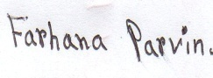
(Farhana Parvin)

