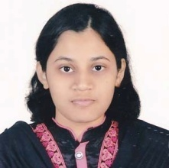
FATEMA BINTE FAZAL
Date of Birth: 14 October, 1996
Mother’s Name: HASINA AKTER
Father’s Name: DR. MD. FAZLUL ISLAM
Address: 179/2 Agrani Londoni Road, Sylhet
Email: aahroo13@gmail.com
Website: 1)
www.instagram.com/oronyani
2) biniaaru.blogspot.com
Objective
A motivated person who wants to secure her position in a reputed organization to apply and process her learnings, knowledge, skills as well as creativity.
Education
Result of Secondary School Certificate: GPA-5; Passing Year: 2013
Result of Higher Secondary Certificate: GPA-5; Passing Year: 2015
Bachelor of Arts in English Language and Literature
Passing Year: 2019
Session: 2015-16
Shahjalal University of Science and Technology, Sylhet
Skills
Highly skilled in the use of computers and the internet, as well as Microsoft Office and internet searches.
Hobbies and Interests
Drawing: mostly fond of sketching.
Learning Languages: now learning Spanish and Russian languages.
Reciting: very much interested in Bengali Literature and reciting Bengali poems.

