Jubair Ahmed Fahim


Vill: House No-14 Vartokhola, P.O: Sylhet Sadar-3100, P.S: Sylhet Sadar, Dist: Sylhet
• +880 1756801844 • fahim8577@gmail.com
• Date of Birth: 09-06-2000
• Marital Status: Single
•Family Members: 06

Personal Statement

Experienced and exceptionally skilled at invigilation and administrative works with a commitment to provide efforts at the highest level. Able to oversee staff and make sure all employees are on task and working as efficiently as possible. Assume the duties of other employees when necessary, including basic office responsibilities, analysis, and report presentations. Excellent communication and problem solving with years of experience as a professional and have a solid understanding of the works of my relevant field. I have an excellent skill in computer and able to manage delegate tasks. Enjoy working in challenging position that will provide future opportunities for growth and development and explores my potential, skills and experience that I have acquired through my education as well as in professional life.

Education

The Aided High School, Sylhet.
(2016)
Secondary School Certificate
GPA 3.78 out of 5.00
Group - Business Studies

Shahporan Govt. College, Sylhet.
(2018)
Higher Secondary Certificate
GPA 2.58 out of 5.00
Group - Business Studies

Work Experience

- As a Computer Operator in a privet sector for 6 month.

Language Proficiency

- Good command over speaking, reading, writing, listening in both Bengali and English Language

Computer Literacy

- Having skills on MS Word, MS Excel, MS Power Point and Internet Browsing.
- Having skill on Bangla and English typing.
- Speed: English-50 WPM, Bangla-20 WPM

Hobbies & Interests

I have a keen interest in debate. I was a member of the debating club during my time at college, and during this period I organised a number of very successful exhibitions and events both on and off campus. I also like travelling and whenever I love get involved in voluntary activities. I also like to reading newspaper in my leisure time. On weekend I like to hangout with my friends.

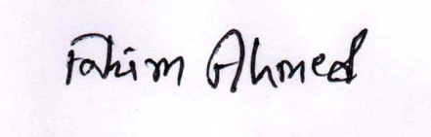

( Jubair Ahmed Fahim) Date:- 23-01-2021

