Fahmeda Yesmin Chowdhury

Muhona 16/B, R/A, Korerpara, Patanthula, Sylhet, Bangladesh.| +8801711164757 | fahmi.1301020006@gmail.com

Dear Sir,
I am Fahmeda Yesmin Chowdhury. I have completed B.Sc. Engineering in Computer Science & Engineering from Leading University, Sylhet, Bangladesh. I believe that my abilities would be a unique asset to your Company/Organization. My own career would also be benefited through being a productive member of your Company/Organization. A quick glance through my resume gives you an idea about it. I assure you that I shall do my best towards the progress of your company/organization.

Thank you for your time and courtesy in viewing my resume.

Sincerely,
------------------------
Fahmeda Yesmin Chowdhury

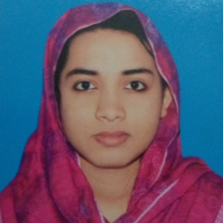
Fahmeda Yesmin Chowdhury
B.Sc. in Computer Science and Engineering
Leading University, Sylhet

Career Objective

I am a Computer Science graduate. To be an astute learner and the best performer in your organization. So that I can build an innovative career in your esteemed organization by using my skills and other significant talents.

Personal Information

Father’s Name : Idrish Ahmed Chowdhury
Mother’s Name : Syeda Fathema Begum
Sex : Female
Date of Birth : 17-01-1993
Nationality : Bangladeshi
Languages Known : Bangla, English
Contact No : 01711164757
Address : Muhona 16/B, R/A, Korerpara, Patanthula, Sylhet, Bangladesh.
Email : fahmi.1301020006@gmail.com

Self-Assessment
- A self-driven attitude, willingness to learn and a strong presence of mind.
- Optimistic, confident and benevolent.
- Energetic, devoted, sincere and hardworking
- Education free for all
- Ability to work with the team and individual and management skills.
- Have experienced about Soft-Skills.
Educational Information

Certification | Institute | Board | Year | GPA/CGPA
SSC | Sylhet Govt. Agragami High School and College | Sylhet | 2009 | 5.00
HSC | Sylhet Govt. Womens College | Sylhet | 2011 | 3.80
B.Sc | Leading University | Leading University | 2017 | 2.83/2nd Class

Computer Proficiency

- Languages : C, C++, Java, Html, CSS, PHP (Basic)
- Platform : Windows
- Word Processing : Microsoft Word
- Speared Sheet Analysis : Ms Excel, Ms Access

Areas of Interest

- Teaching.
- Working with new technology.
- Helping People.
- Sharing innovative thoughts with the community/society.
Final Year Project in University

Online Food Application: Based on online food ordering system.
Position : Font-end developer and content writer.
Extra and Co-curricular Activities

- Senior Executive Member Of Leading University Computer Club (2014-2015)
- Well Communication Skills
- Proficient in Microsoft Office (Word, PowerPoint, Excel)

References
Bahlul Siddiquee
Junior Software Engineer
SJInnovation LLC, New York , USA
Official Email : bahlul.siddiquee@sjiinovation.com
Personal Email : bahlul.tausif@gmail.com
Contact : +8801731-691994
Skype : tausif.rockstar

