CURRICULUM VITAE
OF
Fahmida Hasnat
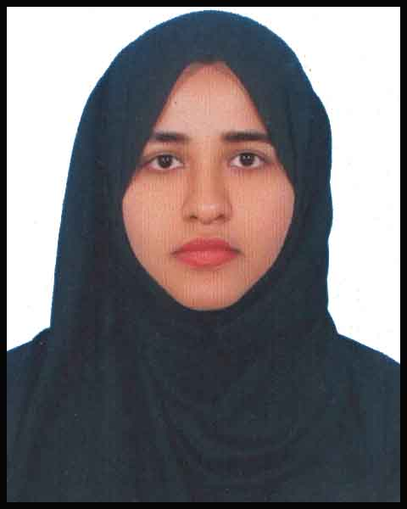
Contact Me At
House: 23, Road: 01,
Ranabhola, Uttara, Dhaka-1230.

Contact No. +88-01877344202
E-mail: fahmidahasnat663@gmail.com

Personal Evaluation:
Honesty, punctuality, hardworking, Patience, good analytical, communication and interpersonal skill, ability to work under pressure, good presentation ability, eager to learn about new techniques and quick learning. I am now looking for an opportunity for my career and personal development within a dynamic environment. Proved myself as an energetic and self-motivated person because of my small experience.

Educational Qualification

Bachelor of Honour’s (B.Sc)
University : Southeast University
Institution : Southeast University Discipline : Pharmacy
Result : 3.45 out of 4.00
Year of Passing : 2018
Higher Secondary Certificate (H. S.C)
Board : Comilla
Institution : B.Baria Govt. Women College
Discipline : Science
Result : GPA – 3.60
Year of Passing : 2012

Secondary School Certificate (S.S.C)
Board : Comilla
Institution : Shahbazpur M.L High School
Discipline : Science
Result : GPA – 4.38
Year of Passing : 2010

Job Experience:
Organization : Global Education
Department : Math Science
Job location : Road: 7, Sector: 9, Uttara, Dhaka-1230
Designation : Asst. Teacher.
Duration : March 2013 to August 2015

Organization : Amina’s Learning Centre
Department : Biology, Chemistry, Math
Job location : Road: 5, Sector: 14, Uttara, Dhaka-1230
Designation : Asst. Teacher.
Duration : February 2014 to November 2018
page 1 of 2

Computer Skills:
Operating System : All Windows Modes
Office Application : MS-Word, MS-Excel, MS- Power Point MS. Access
Internet : Internet Browsing & E-mail Usage

Language Proficiency:
Language | Reading | Writing | Speaking
Bengali | High | High | High
English | High | High | Medium

Personal Information

Father’s Name : Late Abul Hasnat

Mother’s Name : Mrs. Khaleda Hasnat

Permanent Address : Village: Shahbazpur, Post: Shahbazpur
Thana: Sharail, Dist: B. Baria

Date of Birth : 31st December, 1993

Nationality : Bangladeshi

Height : 5 feet 6 inches

Marital Status : Married

Blood Group : A (Positive)

Other Skills & Qualifications
- Excellent interpersonal communication skills.
- Hard working and able to organize a heavy workload with competing deadlines.
- Efficient in the management and self motivated. Good analytical aptitude.

Interest
Internet browsing, traveling, listening music, reading novels

Reference

1.  Md. Siddiqur Rahman  Chairman  Department of Pharmacy  Southeast University  Cell:  E-mal: siddiqueseu743@gmail.com | 2.  Riyad Uddin  General Manager  Regent Airlines  Dhaka  Cell: 01748-435563  E-mail:

Declaration
I the undersigned certify that to the best of my knowledge and belief this all the information correctly describes my qualifications and my self. I understand that any willful misstatement described here in may lead to my disqualification or dismissal, if I am employed.

Fahmida Hasnat

Date…………….
page 2 of 2

