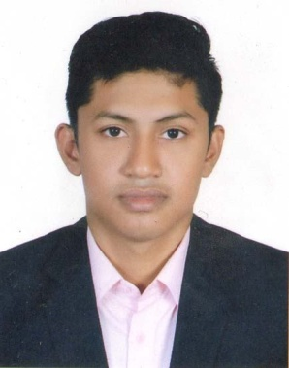
Resume

Of

Faisal Md. Irfan Mobile No: 01829327899
e-mail:faisalnirfan99@gmail.com
Career Objective :
To take a challenging job demanding hard work and integrity for exploring my potentials and
capabilities.

Educational Qualifications:

Masters of Business Administration(MBA):
Name of Institution : East Delta University Chittagong
Major : Marketing
Year of Passing : 2019
Result : 3.43
Bachelor of Business Administration(BBA):
Name of Institution : International Islamic University Chittagong. Major : Marketing
Year of Passing : 2018
Result : 3.179

Higher Secondary Certificate (HSC):
Name of Institution : Ispahani Public School & College Group : Business Studies
Year of Passing : 2013 Result : 4.90

Secondary School Certificate (SSC):
Name of Institution : Chittagong Ideal High School
Group : Business Studies Year of passing : 2011
Result : 4.88
Personal Details:
Name : Faisal Md. Irfan
Father’s name : Hazi Faridul Alam
Mother’s name : Shamsun Nahar Begum
Date of birth : 07-04-1994
Marital status : Single
Religion : Islam
Nationality : Bangladeshi by Birth.

Present address : 7/E, Shakila Jahan Villa 3rd Floor,
Hazi Omdadul Islam Lane,

Devpahar, Chawkbazar, Chittagong.
Parmanent address : Vill- Hathiarkul, P.O- Shanarhat, P.S - Satkania,
Dist-Chittagong.

Language Proficiency:

Language | Reading | Writing | Speaking
Bangla | High | High | High
English | High | High | Medium

Hobbies:
Listening music , Playing Cricket, Reading articles and books, Writing poems, Traveling, Working in new environment and Befriending people.

Experience:

- Completed Internship from United Commercial Bank, Anderkilla Branch, Chittagong
- Completed Computer Office Management Course- (Trouble Shooting, MS Word, MS Excel, MS power point, MS Access, Basic, e-mail & Internet) from Digital Computer Academy, 2, Inner Corridor, Shahajada Market, Chawkbazar, Chittagong-4203.

My Strength :

As an energetic and hard worker person. I would be able to work Under pressure and strain.

Having capability of inter personal communication and self decision-making, I am able to Successfully meet the crucial challenge of the situation.

- I am purposeful, focused, honest, punctual, realistic, balanced and confident.

- By the grace of Allah the almighty, I can learn anything very quickly.

- I like challenges and enjoy Challenges, I am never stack in doing my duties.

I, the undersigned, do hereby certify that to the best of my knowledge the CV correctly describe me and my qualification Thanks for going through my CV.

With best regard,

Faisal Md. Irfan

