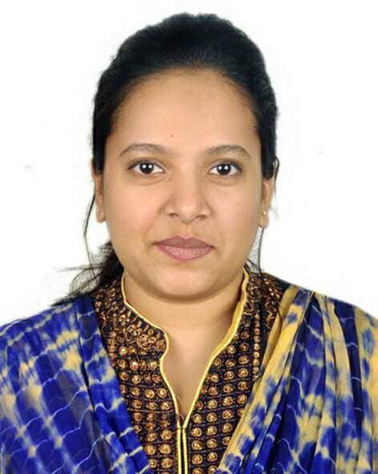
Resume of
Farhana Islam

House: Uttoron – 49, Baruthkhana, Sylhet – 3100
Mobile: 01755468988
01676023837
Email: farhanaislamtuli93@gmail.com

CAREER OBJECTIVE

I am willing to work in challenging and competitive environment where a strong sense of responsibility and commitment is required. Where dignity of work provides job satisfaction and the workplace provides potential avenues for learning, improving personal qualities and achieving top level in the pecking order of the field.
KEY SKILLS
- Ambitious and Self-motivated person and flexible with an ability to acclimatize to changing environment.
- I am quite creative, and can really shine when it comes to thinking outside the box.
- I am usually really organized, and plan my day well. In most situations, I am able to deliver on time by effectively managing usual hours at work.

WORK EXPERIENCE
Institution Name | Designation
- Consultant in Ceragem (Therapy Center).  - The Osmani Ideal International School. | -November 2014 to July 2015.  -Assistant Teacher  (January 2017 to Present).

Major Job Responsibilities
- To teach students of NationalCurriculum& British curriculum .
- Prepare assessment report for individual student.
- Everyday send work report to authority.

ACADEMIC QUALIFICATIONS :
Masters of Arts (M.A)
Major : Islamic History & Culture
Name of Institution : M.C College
CGPA : 2.73 ( Out of 4)
Passing year : 2015
Bachelor of Arts (B.A Hon’s)
Major : Islamic History & Culture
Name of Institution : M.C College
CGPA : 2.61 (out of 4)
Passing Year : 2014
Higher Secondary School Certificate (H.S.C)
Name of Institution : Madan Mohan College, Sylhet
Name Of Board : Sylhet.
Group : Humanities
Result (GPA) :2.60 (Out Of GPA 5.00)
Passing Year : 2009
Secondary School Certificate (S.S.C)
Name Of Institution : Sylhet Govt. Agragami Girl’s High School, Sylhet
Name Of Board : Sylhet
Group : Humanities
Result (GPA) : 3.50 (Out Of GPA 5.00)
Passing Year : 2006
COMPUTER SKILLS

Microsoft Office word, Microsoft Office Access, Microsoft Office Power Point.
Internet Browsing , Downloading, E-mailing, and all kind of work which is related by internet.

LANGUAGE SKILLS
- Have good command over Bengali and English language in four modules- Reading, Writing, Speaking and Listening.

- INTEREST AND HOBBIES
- My interest includes going out with friends and socializing, watch television, reading newspaper, using internet . My hobbies are travelling to many places and listening music.

PERSONAL INFORMATION
Full Name : Farhana Islam
Father’s Name : Md Abdush Shahid
Mother’s Name : Anwara Islam
Permanent Address : Uttoron -49, Baruthkhana, Sylhet
Present Address : As Above
Date of Birth : 10/01/1991
Nationality : Bangladeshi (By Birth)
Religion : Islam
Marital Status : Single

REFERENCE

Humayun Kabir Chowdhury
Assistant Professor
Department Of Islamic History & Culture M.C College , Sylhet
Phone: 01558398290
I hereby, state that all information mentioned above is absolutely correct to the best of my knowledge and belief and necessary documents could be provided if demanded.

Your Sincerely Date:
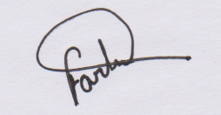…
(Farhana Islam)

