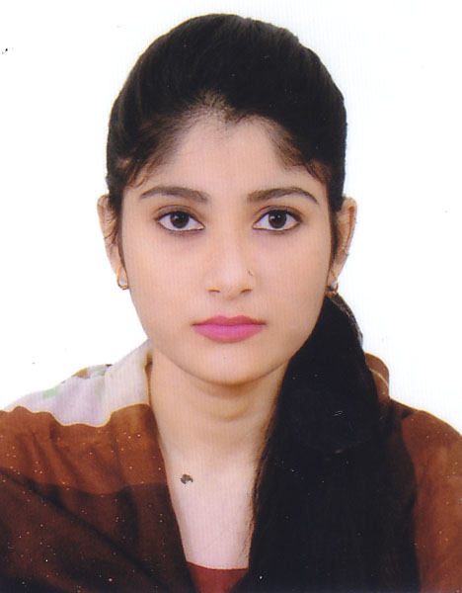
Farzana Rahman Chumki
Chayanir-5/1, Soroshpur
Lamabazar, Sylhet-3100
Mobile: 01724-972274
E-mail: farzanar465@gmail.com

Career Objectives:-

To be efficient and successful in work and build up strong career in the respective field, to obtain a position where I could utilize my skills. Want to work in a favorable environment in a suitable and organization with challenge.

Educational Qualification:-

Masters of Arts (M.A)
Institute Name : M.C College, Sylhet
Subject : English
University : National University
Result : Running
Bachelor of Arts (B.A)
Institute Name : M.C College, Sylhet
Subject : English
Passing Year : 2015
University : National University
Result : 2.74
Higher Secondary Certificate (H.S.C)
Institute Name : Govt. Women's College, Sylhet
Subject : Humanities
Passing Year : 2011
Result : 4.30
Board : Sylhet
Secondary School Certificate (S.S.C)
Institute Name : Sylhet Govt. Agragami Girls High School.
Subject : Humanities
Passing Year : 2009
Result : 4.50
Board : Sylhet

Computer Skills:-
- Office Application: MS Word, MS Excel, Power Point.
- Internet Suffering & Emailing.
Time Management:

- Attended all academic and professional activities in time.
- Properly maintained the time of my class.
- Successfully done my time for travel arrangement and household occasion.

Language Proficiency:

- Bangla : Fluent in Reading, Writing & Speaking
- English : Fluent in Reading, Writing & Speaking

Personal Information:-

- Name : Farzana Rahman Chumki
- Father’s Name : Md. Ataur Rahman
- Mother’s Name : Anarkoli Chowdhury
- Permanent Address : Chayanir-5/1, Soroshpur, Lamabazar, Sylhet-3100.
- Date of Birth : 12 October 1993
- Sex : Female
- Marital Status : Single
- Nationality : Bangladeshi (By Birth).
- Religion : Islam

Skills:-

- Willingness to work hard necessary to developed career.
- Self-Motivation
- Good Communication Skill.
- Teamwork

Reference

Muhammad Amirul Islam
Assistant Professor
Department of Economics
Sylhet Govt. College
Mobile: 01712-575396
E-mail: maib_syl@yahoo.com
Md. Harunur Rashid
Director
Secondary & Higher Education
Sylhet Zone, Sylhet
Mobile: 01979311901

I hereby declare that the information given is correct to the best of my knowledge.

