Resume of
Fatema Akter
Contact & Mailing Address |  | Photo
FatemaAkter  ManullahFouzdarBari,KalushahNagar,MiddleSalimpur,  Jafrabad,Sitakunda,  Chittagong  E-mail:rima777251@gmail.com  Cell:01533028083 |  | 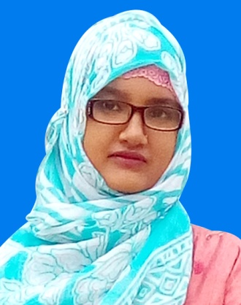
Personal Factors
Name | FatemaAkter
Father’s Name | Md.GiasUddin
Mother’s Name | Laila Begum
Date of Birth | 1stNovenber 1996
Place of Birth | Chittagong
Marital Status | Married
Religion | Islam
Nationality | Bangladeshi
Permanent Address
ManullahFouzdarBari,KalushahNagar,MiddleSalimpur,Jafrabad,Sitakunda,
Chittagong

Carrier Objectives
To buildup career with leadership,teamwork,maintaining public relation and excellent communication,solidproficiency,strong command and expensive accountability and willing to work for public service.

Educational Qualification

Course Name | Diploma in Engineering
Name of Institution | Chittagong Mohila Polytechnic Institute
Department | Computer Technology
Result | GPA-3.19(out of 4)
Board | Dhaka
Passing Year | 2018

Course Name | Dakhil(S.S.C)
Name of Institution | HajratKhawjaKalu Shah (Rh:) SunniaAlimMadrasha
Group | Science
Result | GPA-5.00(out of 5)
Board | Dhaka
Passing Year | 2012

Experience
1.Internship at Link3 Technologies
Duration:3 months
2.Teacher at Little Birds Ideal School
Duration:1 year

Others Skills
Language Proficiency
English : Spoken is Moderate and Written is excellent
Bengali : Spoken and Written is excellent
Signature

