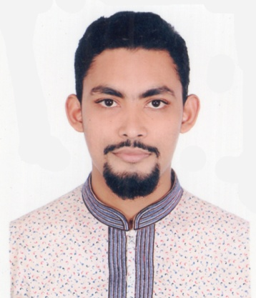
Mailing Address:
CURRICULUM VITAE
OF
MD. FAYEZ AHMED

House # 5 (2nd Floor)
S R Park, Shahjahan Sir Market
Hazaribagh, Dhaka-1209.
Mobile # 01675686937
E-mail: fayezahmed4747@yahoo.com

Career objective:

I would like to show my immense aspiration to become a quick learner and prove myself as a sincere, self-motivated and energetic person through hard work and integrities, I would like in any challenging and dynamic position in any organization.

Educational Qualification:

B.B.A (Hon’s)
University : Northern University Bangladesh
Department : BBA
Passing Year : On going
Result : CGPA 3.00
Major in Finance

Higher Secondary Certificate (H.S.C)
Institute : Dhaka City College
Group : Humanities
Passing Year : 2012
Result : GPA 4.80
Board : Dhaka

Secondary School Certificate (S.S.C)
Institute : Shukarabad High School
Group : Business Studies
Passing Year : 2010
Result : GPA 4.44
Board : Dhaka

Dawratul Hadis:
Institute : Anowarul ulum Madrasha
Group : Dawra Hadis
Passing Year : 2016
Result : Pass
Board : Bangladesh Kowmi Madrasha Board

Al Quran Hafez:

Institute : Siddikiya Hafizia Madrasha
Group : Hefj
Passing Year : 2007
Result : Pass
Computer Skill:

Microsoft Word, Microsoft Excel, Microsoft Power Point, Internet Browsing, Photoshop & Graphic Design (Intermediary Level).

Language Proficiency:

English : Reading, Writing, Understanding and Speaking
Bengali : Native
Experience:

- Organization Name : Mastul Foundation.
Name of Position : Deputy General Secretary.

- Organization Name : BRAC.
Name of Position : Field Research Assistant .
Name of Project : Baseline Survey of BPS (BRAC Primary School)
IIEGRA Project (with tab).

Extra-curricular activities

I have been doing my own travelling business which is called Travelers of Asia since December,2016 to till now.

Personal Information:

Name : Md. Fayez Ahmed
Father’s Name : Nurur Rahman
Mother’s Name : Mrs. Mortuza Rahman
Permanent Address : Vill: Kabilpur, P.O: Porkara
P.S: Sonaimuri, Dist: Noakhali
Date of Birth : 11-10-1995
Height : 5’ 5” Inc
Religion : Islam
Marital Status : Single
Gender : Male
Nationality : Bangladeshi

Declaration:
I the undersigned, certify that the above information is true, complete and correct to the best of my knowledge and belief. These date correctly describe my qualification and me.

Signature:

( Md. Fayez Ahmed)

Dated:

