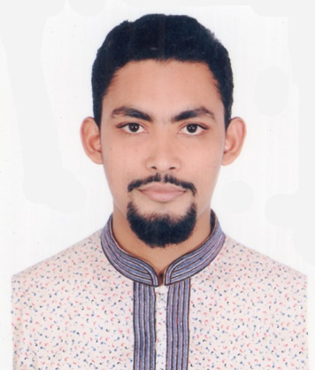
Curriculum vitaeof

Md.Fayez Ahmed
Mobile: +8801675686937
E-mail: mdfayezahmed47@gmail.com
Address: 22/2, Tenarymore, Zigatala, Dhaka-1209

CAREER OBJECTIVES

To enhance my professional skills in a corporate dynamic working place where I can leverage my strong result-oriented skills at solving problems efficiently with solving skills, excellent interpersonal and communication skills through achieving the goals of the organization.

ACADEMIC QUALIFICATIONS
2020 | BBA  Major in Finance & Minor in Accounting  Northern University Bangladesh  CGPA: 3.03 on a scale of 4.00
2012 | HSC  Dhaka Board  Humanities  Dhaka City College  GPA: 4.80 on a scale of 5.00
2010 | SSC  Dhaka Board  Business Studies  Sukarabad High School  GPA: 4.44 on a scale of 5.00
2016 | Dawra Hadis  Dhaka Board  Bangladesh KowmiMadrasha Board  Anowarul Ulum Madrasha (Hazaribagh)  Result : Pass
2007 | Al Quran Hafez  Siddikiya Hafizia Madrasha (Zigatala)  Result : Pass
WORK EXPERIENCES

Organization : Mastul Foundation
Position : Deputy General Secretary
Working Period : 1st July 2015 to 26th November 2017
Company Address: 22 no Nimtoli, rayerbazar, Dhaka-1209.

Organization : Travellers of Asia
Position : Managing Director
Working Period : 1stfebruary 2014 to 30th December 2019
Company Address: 22/2 Ternary more zigatala, Dhaka-1209.

Organization : Islami Bank Training and Research Academy
Position : Internship
Working Period : 1st October 2020 to 29th November 2020
Company Address: 13A/2A Babar Road,Block #B,Mohammadpur,Dhaka-1207

TECHNICAL SKILLS

Computer Skills
1) Microsoft Word.
2) Microsoft Excels.
3) Microsoft PowerPoint

Language Skills 1) Speak& Write Bengali & English
fluently 2) Speak & Understand Hindi

Interpersonal Skills
1) Good in communication
2) Skilled in networking

KEY COMPETENCIES

- Expert knowledge in finance and Accounting sector.
- Hard working and meeting deadlines.
- Ability to work in team environment.

HOBBIES & INTERESTS

- Reading books.
- Watch movies and listening songs.
- Travelling.

CONTACT DETAILS

Current Address: S.R Park, Sahjan Sir Market, Hajaribagh, Bribed. Dhaka-1209

Permanent Address: kabilpur, Sonaimuri, Nowakhali,

Contact Mobile: +88001675686937
Email: mdfayezahmed47@gmail.com

PERSONAL DETAILS
 | Father’s name | : | Nurur Rahman
 | Mather’s name | : | Mortuza Rahman
 | Date of birth | : | 11 October, 1995
 | Sex | : | male
 | Nationality | : | Bangladeshi
 | Religious | : | Muslim
 | Height | : | 5′ 6′′
 | Marital status | : | Unmarried
REFERENCES
1# Md. Mizanur Rahman

Senior Principal Officer
Islami Bank Bangladesh Limited
Contact No: +8801913669296

2 # Md. Shoriful Islam
Assistant Professor
Department of Finance
Northern University Bangladesh
E-mail: shorifnub08@gmail.com
Contact No: +8801755514692

Md.Fayez Ahmed
Date: 17th Octobor, 2020

