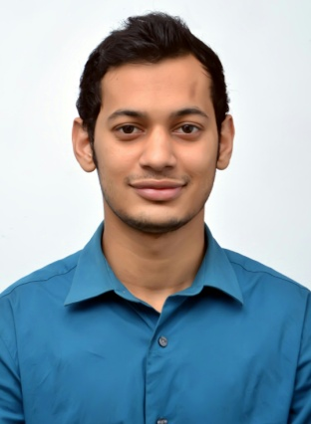

Curriculum vitae
Of
Fazly Rabby

Contact

Cell: +880 1719-233159
E-mail:fazlyrabby49@gmail.com
41/A, Kumarpara, Sylhet

ABOUT ME

personally type of person who gives priorities on satisfaction. I will work hard if I love the job & if it satisfies me. And psychologically I am that type of person who can take positives and negatives, mean’s I accept the negatives & improve from the positives.
CAREER OBJECTIVE

Believe in efficiency and accuracy in accomplishing any job with effective communication skill, positive and helping attitude, ability to work under pressure in a team or individual.
PERSONAL INFORMATION

Name : Fazly Rabby

Father’s Name : Md. Azir Uddin

Mother’s Name : Nila Chowdhury

Date of Birth : 20th December 1995

Nationality : Bangladeshi

Religion : Islam

Marital Status : Single
Present address : 41/A, Kumarpara, Sylhet
Permanent address :vill:Gangkul, post office: Dakshinbagh,
Upazilla:Barlekha. District:Moulvibazar.

2016: Bachelor of Business Administration
ACADEMIC QUALIFICATIONS

National University of Bangladesh.
CGPA –2.93 out 4
Major: Accounting

2012: Higher Secondary Certificate
Madan Mohan College, Sylhet.
Sylhet Board.
GPA- 4.60 out of 5
Group: Business Studies

2010: Secondary School Certificate
Sylhet Government Pilot High School, Sylhet.
Sylhet Board.
GPA- 4.69 out of 5
Group: Business Studies
COMPUTER SKILLS

I have good hand on Ms Office, Adobe Photoshop, Adobe Illustrator & have a good knowledge in internet surfing, mailing etc.
PERSONAL SKILLS

- Perform with in team or individual capacities.
- Have a friendly and responsible nature.
References

Professor Pradip Kumar Dey
Head Of Accounting Department
Madan Mohan College, sylhet
Cell: +8801711-394519

Bodrul Islam Monu
Senior Lecturer
Department Of Bangla.
T. N. Khanam Academy Degree College ,Moulvibazar.
Cell: +8801718-252329

I certify that all information stated in this resume is true and complete to the best of my knowledge and that I authorize the recipient to verify the information provided.
Signature

