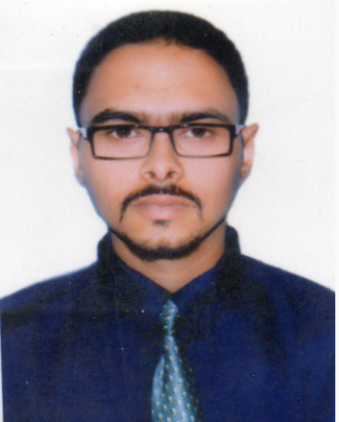
Curriculum Vitae
Of
RAJU TALUKDER

E-mail:rajutd1994@gmail.com
Cell No: +8801770076772

Profile | Enthusiastic, energetic, responsible with good English skill and good relationship development, strong interpersonal, organizational and communication skill. Able to work independently by using initiative and as a part of a team to tight deadlines.
Objective | Seeking challenging and responsible career opportunity where I will be able to exercise my skill and knowledge in a competitive environment to the attainment of the objectives of my organization through creative solution.
Educational Pursuit | Four-Years Degree (Hon’s)  Institution: Sylhet International University.  Subjcet : English.  Session: 2013  Passing year: 2017  Result: 2.93.  Higher Secondary Certificate  Institution: Madan Mohan College University.  Board: Sylhet  Group: Business studies.  Year of Passing: 2012  Result: GPA-3.30  Secondary Certificate  Institution: Pathantula Bilatrial high school  Board: Sylhet  Group: Humanities  Year of Passing: 2010  Result: GPA-3.63
Computer Pursuits | ❑ Applications Software: Strong command over Microsoft Office (Word, Excel, Power Point, Access), Presentation Related (Adobe Photoshop, Adobe Illustrator).
Pronunciation Skill | ❑ Good pronunciation skill in Bangla & English & voice is clear & Strong.  ❑ Good organizational Capacity.  ❑ Ability to work in a multicultural team environment.  ❑ Ability to maintain good inter personal relationship.  ❑ Can learn new package quickly.
Extra-Curricular activities | - General Secretary , Charyapath Reciting club.  - Organizing Secretary, Samakal Suridh Samabesh.
Experience | 1.Project supervisor of Swapno Bangla Group.(6 month)  2. Circulation Manager, Sylhet Zone,  Daily Banik Barta. (6 month)  - Research Firm  - Neilsen Bangladesh Ltd, Project supervisor (running)  - BATB  - Luminaries Research Limited
Personal Details | Name : Raju Talukder  Father's Name : Late Ranjit Taluder  Mother's Name : Joba Talukder  Mailing Address : Muhona Block,b/66, Korerpara, Sylhet.  Permanent Address : As Above.  Date of Birth : 06.12.1994  Religion : Sanatan.  Blood Group : 0+  Sex : Male  Nationality : Bangladeshi (By Birth)  Marital Status : Single
Mizanur Rahman Chowdhury Mr. Pronab Kumar Saha
Senior Assistant Vice president & Manager. Professor, dept, of BA,
Laldighirpar Sylhet Branch, National Bank Limited. Sylhet International University.
Phone: 0821-715882. E-mail:pronab.saha08@gmail.com
Email:Sylhet@nblbd.com Mobile: 01914706933

Thank you, for your review and consideration of my qualifications.

Sincerely,
Date : 26-03-2019 Raju Talukder

Reference:

