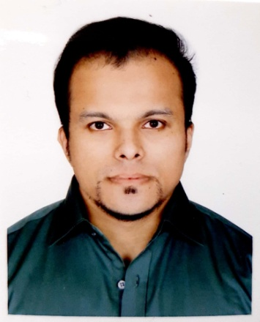
RESUME
OF
MD. NAVID NAZIM
Contact Address:
House# 50. Road# 01, Sector# 06,
Uttara, Dhaka-1230.
Contact No: +88 01817182280
E-mail: navid.works@gmail.com

Career Objectives:
In the beginning of career I’m highly desired to work in a reputed organization where I shall be able to explore my capabilities and gradually develop knowledge, skill and abilities to perform duties and responsibilities efficiently and effectively to and values to my organization where I will find ample scope and opportunity to work and to promote to a significant position.

Educational Qualifications:

Masters of Business Administration
Institution : American International University of Bangladesh
Major : Human Resource
Passing Year : Running
Bachelor of Business Administration
Institution : Asian University of Bangladesh
Major : Marketing
Passing Year : 2008
Result : CGPA- 3.45 (Out of 4.00)
Higher Secondary Certificate (HSC)
Institution : Notre Dame College
Group : Commerce
Board : Dhaka
Result : 1st Division
Secondary School Certificate (SSC)
Institution : National Bank Public School & College
Group : Commerce
Board : Dhaka
Result : 1st Division
Language Skill:

Language | Reading | Writing | Speaking
English | Excellent | Excellent | Moderate
Bengali | Excellent | Excellent | Excellent

Computer Skill:

- Application Package : MS Word, MS Excel, MS PowerPoint
- Internet Access : Mail check
- Others : Multimedia & Hardware
Experience:

1. Company name : ROBI, The Axiata Limited
Position : Specialist
Dept : Market Operation
Time Period : May 2010- 2013
Address : Gulshan-1, Dhaka

2. Company name : Genex Infosys Limited
Position : Specialist
Dept : Operations

Job Responsibility : Customer Service Team Leader:
# Working for daily service level target.
# Leading& control 18 members team
# Team performance evaluates & update on daily basis
# Monthly KPImonitors to maintain best performance.

Floor Monitoring:
# Maintain floor offer call & answered call%
# Maintain break management according to requirements.

Attending Robi product training, other business channels, sms & email
# Regular taking update regarding robi product& offer
# Attending International roaming critical calls
# Regular update product related business mail.
Time Period : July 2013 to till now
Address : Mascot Plaza, Uttara, Dhaka

Personal Details:
Name : MD. Navid Nazim
Father’s Name : Nazim Uddin Ahmed
Mother’s Name : Nasima Ahmed
Date of Birth : 18th December, 1984
Permanent Address : 284 Gulbag (Malibag) Dhaka- 1217
Marital Status : Married
Sex : Male
Nationality : Bangladeshi (By birth)
National Id Card No : 2695435976647
Religion : Islam
Health : Excellent, Non-smoker
Blood Group : AB+

Declaration:

I hereby certify that the above information given in this resume is true and complete to the best of my knowledge and belief.

MD. Navid Nazim

Date:………………………….

