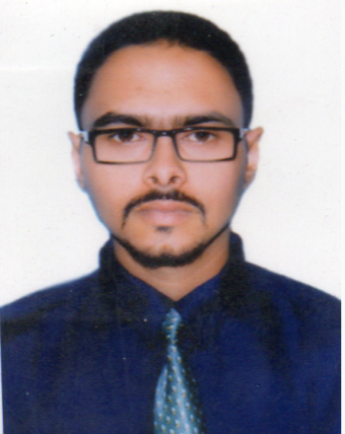
RAJU TALUKDER

Mail:rajutd1994@gmail.com Cell No: +8801770076772

Profile | Enthusiastic, energetic, responsible with good English skill and good relationship development, strong interpersonal, organizational and communication skill. Able to work independently by using initiative and as a part of a team to tight deadlines.
Objective | Seeking challenging and responsible career opportunity where I will be able to exercise my skill and knowledge in a competitive environment to the attainment of the objectives of my organization through creative solution.
Educational Pursuit | Four-Years Degree (Hon’s)  Institution: Sylhet International University.  Subjcet : English.  Session: 2013  Passing year: 2017  Result: 2.93.  Higher Secondary Certificate  Institution: Madan Mohan College University.  Board: Sylhet  Group: Business studies.  Year of Passing: 2012  Result: GPA-3.30  Secondary Certificate  Institution: Pathantula Bilatrial high school  Board: Sylhet  Group: Humanities  Year of Passing: 2010  Result: GPA-3.63
Computer Pursuits | ❑ Applications Software: Strong command over Microsoft Office (Word, Excel, Power Point, Access), Presentation Related (Adobe Photoshop, making slideshow).
Pronunciation Skill | - Good pronunciation skill in Bangla & English & voice is clear & Strong.  - Good organizational Capacity.  - Ability to work in a multicultural team environment.  - Ability to maintain good inter personal relationship.  - Can learn new package quickly.
Extra-Curricular activities | - Founder member & General Secretary, Charyapath Reciting club.  - Ex-Organizing Secretary, Samakal Suridh Samabesh.  - Founder member, Siu cultural association.
Experience | 1.Project supervisor of Swapno Bangla Group.(6 month)  2. Circulation Manager, Sylhet Zone,  Daily Banik Barta. (6 month)  3. Research Firm  - Neilsen Bangladesh Ltd, Project supervisor  - BATB  - Luminaries Research Limited  4.Till rolls call center (3 month)  5.Cash maintain of Panshi Bazer (super shop)
Personal Details | Name : Raju Talukder  Father's Name : Late Ranjit Taluder  Mother's Name : Joba Talukder  Mailing Address : Muhona Block,b/66, Korerpara, Sylhet.  Permanent Address : As Above.  Date of Birth : 06.12.1994  Religion : Sanatan.  Blood Group : 0+  Sex :Male  Nationality : Bangladeshi (By Birth)  Marital Status : Single
Reference:
Mizanur Rahman Chowdhury Pulok Talukder
Senior Assistant Vice president & Manager. Senior officer
Laldighirpar Sylhet Branch, National Bank Limited. Sonali bank ltd.
Phone: 0821-715882. Contrct:01729590710
Email:Sylhet@nblbd.com .

Thank you, for your review and consideration of my qualifications.
(…………………………..)
Date : 07-08-19 Raju Talukder

