Date: 20-06- 2020

To

The Managing Director,

Bangladesh Red Crescent Society
Subject: Application for the post of “Staff Nurse”.

Dear Sir,
I came to know from a reliable source that your institution have requested some persons for the post of “Staff Nurse”. I am hereby offering myself as a candidate for the post. My resume and other necessary documents are enclosed here with for kind consideration.

I would be grateful to you, if you kind enough to call me to an interview and hereby give me an opportunity to be a part of your institution and contribute my best as well.

Sincerely Yours

Mohammad Toyabur Rahaman

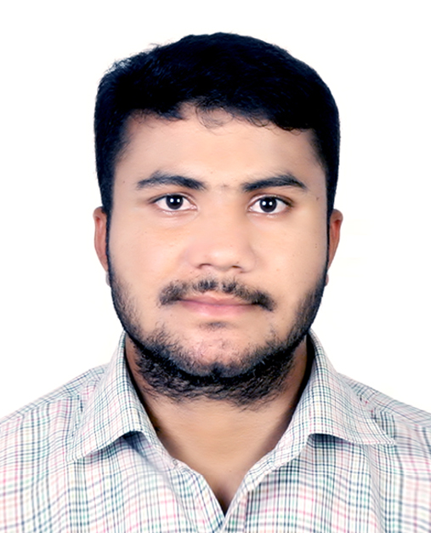

TOYABUR RAHAMAN BHUYA Sylhet.
Contact Numbe 01745-840418
Email frahaman.edu@gmail.com

CAREER OBJECTIVE

To work at teaching position in any fast growing institution with immense responsibility so that my situational and transformational leadership style, communication skill, problem solving skill, demonstrative skill, academic knowledge and part-time working experience can be solely utilized to bring a positive change in the institution and that makes me confident, improves my potentiality and gives me an opportunity for my personal improvement along with the improvement of my institution and gives me an opportunity to devote myself for enlightening my nation in the field of teaching.
RECORDS OF EDUCATION

Level : Masters of Clinical Social Work
Name of Institution : Institute of Social Welfare and Research
Name of University : UNIVERSITY OF DHAKA
Academic Year : 2018-2019
Level : Bachelor of Science in Nursing (BSN)
Name of Institution : Begum Rabeya Khatun Chowdhury Nursing College, Sylhet.
Name of University : Shahjalal University of Science & Technology, Sylhet, Bangladesh
Academic Year : 2013-2014
Year of Passing : 2018
Class Obtained : Passed (Average Marks: 70%)
Level : Higher Secondary Certificate (HSC)
Name of Institution : sreemangal govt college
Name of Board : Sylhet
Area of Study : Science
Academic Year : 2011-2012
Year of Passing : 2013
GPA : 3.20
Level : Secondary School Certificate (SSC)
Name of Institution : Bhunabir Dasharat High School
Name of Board : Sylhet
Area of Study : Science
Academic Year : 2010-2011
Year of Passing : 2011
GPA : 3.19

PERSONAL INFORMATION

Name MOHAMMAD TOYABUR RAHAMAN BHUYA
Father’s Name MOHAMMAD RAFIKUL ISLAM BHUYA
Mother’s Name MOSAMMAT HOUSNA BEGUM
Present Address Universal Medical College and Hospital Staff Hostel Mohakhali Dhaka
Permanent Address Vill-Shason, P.O.- Bhunabir, P.S.-Sreemangal, Dis.- Moulovibazar
Contact Number +8801745-840418
Email frahaman.edu@gamil.com
Date of Birth 15 may, 1995
Sex Male
Height 162.5 cm
Weight 70 kg
Nationality Bangladeshi
NID No 4605288309
Religion Islam
Marital status :Married

WORKING EXPERIENCES

- Lecturer universal Nursing College ,Mohakhali Dhaka
- Staff Nurse CICU-section Universal Medical College and Hospital Dhaka
- 4 years clinical practice during the course
- Patient care & Health promotion and education
- Case study & Case presentation
- 6 months internship at Jalalabad Ragib Rabeya Medical College & Hospital, Sylhet.
- Teaching in a well known coaching centre since January, 2015
- Working experience of 1.5 years as a research assistant.
- Completed a study project in the fourth year of Bachelor Degree on “
- On course on clinical social worker
OTHER QUALIFICATIONS

Language skill : Fluent in Bangla and English.
Computer skill : Skilled in MS word, MS excel, MS power-point, SPSS and Software R.
Interest :Reading books, teaching and travelling, playing.
Research Assistant: Undergraduate Research Organization

REFERENCES
- Dr. Rezuana Siddik
M.B.B.S –MD (D Card)
Associate Professor
Universal Medical College and Hospital
Cell: +880 1914-332288

2. Prof: Dr :Shahin Khan
PHd (Social Work)
University of Dhaka
Cell: +88001611-209752

3. Prof:Dr.Sahansah Bappi
MBBS (MPH) (NSU)
Associate Professor
National Medical College and Hospital
Cell: + 01535135965

I, the undersigned, certify that, to the best of my knowledge and belief, these Curriculum Vitae correctly describes me and my qualifications.

Your kindest regards

TOYABUR RAHAMAN BHUYA

……………………………………..

BSN (SUST),
MSS(DU)
RN,ID-9659

