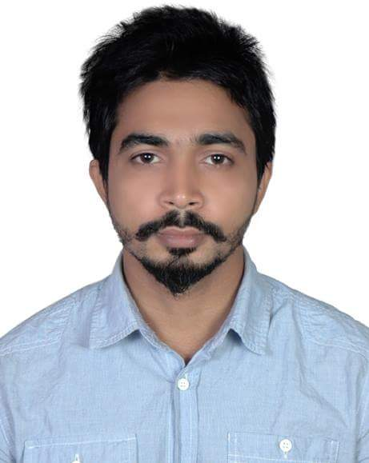
Mailing Address:
C/O: AROJ MIAH
House No: 47/A
Housing state, Amborkhana, Sylhet
Cell: 01719-389341
Email: habiblu117@gmail.com
Resume of Habibur Rahman

Career Objectives
To make a career as a higher executive in the field of financial organization. Be an effective leader and have the authority to influence other. Work in a challenging manner. Maintain discipline properly. I will always look for the opportunity to implement any innovation toward the organization.
Key Qualification

Bachelor of Business Administration (BBA)
Department of Business Administration
Leading University, Sylhet
University website: www.lus.ac.bd
Student ID: 1203010117
Major in: Marketing
Course duration: 4 years
Passing Year: 2017

Detailed Qualification:
Name of Exam | Institute | Passing year | GPA/CGPA | Concentration
BBA | Leading University, Sylhet | 2017 | 2.51 out of 4.00 | Business Administration
HSC | Royal MC Academy, Sylhet | 2012 | 4.32 out of 5.00 | Business Management
SSC | Sylhet Model School & College, Sylhet | 2010 | 3.69 out of 5.00 | Commerce

Other Qualification:
- Computer skill: well exposed to different computer software (MS-Word, MS-Excel, MS- Power Point) operating system Windows 7, Windows 8, Windows 10 as well as Windows XP, Windows 2000, Browsing Internet etc.
- Language skill: Standard in Bengali, Fair in English.
  - Hobbies: listening to music and reading story books, watching movie, try to experience new technology like apps, device and so on.

Personal Qualification
- Ability to work in team.
- Well communication skill to others & co-operative.
- Ability to influence & get attention to other.
- Good presentation skill.

Personal Information
- Name : Habibur Rahman
- Father’s Name: Aroj Miah
- Mother’s Name: Rehana Khanom
- Date of birth : 19-04-1991
- Religion : Islam
- Nationality : Bangladeshi
- Marital status: Single
- Contact No : 01719-389341
- Present Address: Housing State, 47/A, Amborkhana, Sylhet
- Permanent Address: South Bhagbari, Chatak,Sunamganj

Reference

Shamsu Uddin
Leading University, Sylhet
Assistant Professor (Marketing)
Leading University, Surma Tower
VIP Road, Taltola, Sylhet
Contact: 01195-399384
Md. Mahbubur Rahman
Leading University, Sylhet
Assistant Professor (MIS)
Leading University, Surma Tower
VIP Road, Taltola, Sylhet
Contact: 01717-019305

Declaration
I declare that the information provided in this CV is correct, true and complete to the best of my knowledge and belief. If any information is found false, incorrect and incomplete or if any ineligibility is detected before or after the interview any action can be taken against me by the authority including cancellation of my candidature.

