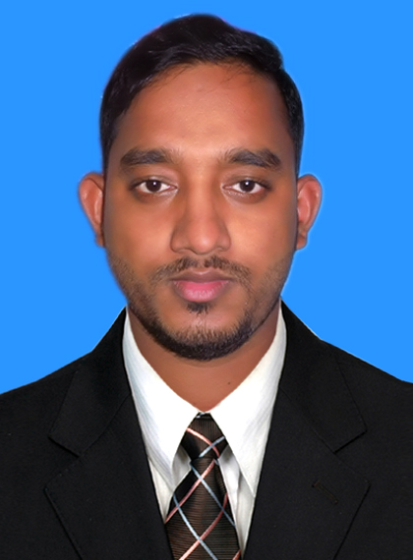
RESUME
OF
Ahsan Habib
Cell No # 01811-986696

CONTACT DETAIL S: Asadgonj, Kotowali, Chittagong.
E-mail : ahsanhabib.1290@gmail.com

CAREER OBJECTIVE
To join an organization where I meet with new challenges and give my best to prove my abilities and achieve the goals in due times efficiently and effectively. I think it's the platform where I can explore my knowledge.

EDUCATIONAL BACKGROUND

Examination : Bachelor of Business Administration (BBA)
Institution : Premier University
Subjec : Finance
Result : 3:12(4.00)
Passing Year : 2018

Examination : Higher Secondary Certificate (H.S.C)
Institution : Gachhbaria Govt. College
Group : Business Studies
Result : 3.60(5.00)
Passing Year : 2012
Board : Chittagong

Examination : Secondary School Certificates (S.S.C)
Institution : Kanchanabad High School
Group : Business Studies
Result : 4.00(5.00)
Passing Year : 2010
Board : Chittagong

LANGUAGE PROFICIENCY:
- Have writing, speaking, and listening ability in both Bengali & English.

COMPUTER LITERACY:
- Application Software: MS office application Word, Excel worksheet, Access, Power point presentation and also I had successfully passed in a BBA related course known as CAB( Computer application in business) and Internet Browsing.

STRENGTHS:
- Friendship.
- Conviction & Motivation power.
- Hard working in under pressure.
- Sharp sense of social responsibility.
- Learning Mentality.
- Strong Communication Skill.

INTEREST & HOBBIES:
- Reading books of different interest.
- Traveling
- Participating in social activities
- Unlock new achievement
- Cricket
- Writing & reading poetry

PERSONAL INFORAMTION:
- Father’s Name : Mahabul Alam
- Mother’s Name : Hosneara Begum

- Permanent address : Vill+po: East Alahabad +Kanchannogor union, 1 no kanchanabad,
Ps: Chandanaish, Chittagong.
- Present Address : Asadgong, Kotowali, Chittagong.
- Date of Birth : 06 Aug 1995
- Gender : Male
- Marital Status : Single
- Home District : Chittagong
- Nationality : Bangladeshi by Birth
- Religion : Islam

DECLARTION:
I thereby consciously ascertain that all the particulars mentioned above are true. I myself well be liable for any misinformation mentioned here with.

Ahsan Habib
__________
Signature

