CURRICULUM VIATE
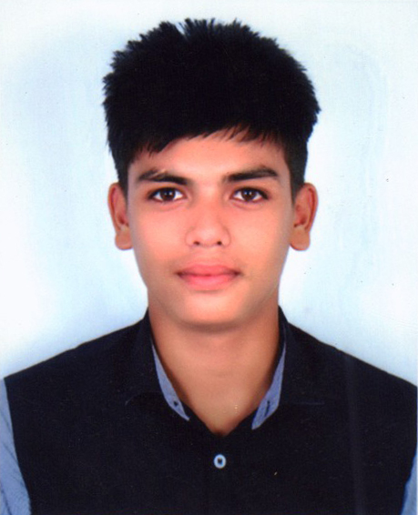
Md. Jahirul Islam Hasan
Villaage : College Road
Post : Chhatak
Upzilla : Chhatak
Dist : Sunamgonj
jahirulislamhasan81@gmail.com
Mobile: +8801778735581

Career Objective:

Seeking a standard position in an educational institution, that provides me a challenging opportunity to combine exceptional interpersonal skills & employing my expertise in related fields.

Academic Qualification

Secondary School Certificate (SSC)
Board : Technical
Institution : Chhatak Technical School and College
Group : Welding and Fabrication
Passing Year : 2015
Roll : 254913
Grade : 4.14 (Out of 5.00)

Higher Secondary Certificate (HSC)
Board : Sylhet Board
Institution : Chhatak Degree College
Group : Business Stady
Passing Year : 2017
Roll : 510147
Grade : 2.17 (Out of 5.00)

Computer Skills:

- Windows operation, MS Office, Internet Operation.
- Short Course Completed On
Content: Computer Application (Computer fundamental, M. S. Word, M.S. Excel, M. S. Access, Power point, Internet, OS & Software Installation)

Experience:

- 6 months working experience as a Computer Training Center.

Personal Information:

1. Name | : Md. Jahirul Islam Hasan
2. Father's Name | : Nurul Islam
3. Mother's Name | : Amina Begum
4. Permanent Address | : Village : College Road  Post : Chhatak  Dist. : Sunamganj
5. Present Address | : Village : College Road  Post : Chhatak  Dist. : Sunamganj.
6. Date of Birth | : 20/10/1999
7. Age | : 18
8. Nationality | : Bangladeshi
9. Marital Status | : Unmarried
10. Home Districts | : Sunamganj
11. Birth Certificate | : 19999022306027637
12. Sex | : Male
13. Height | : 5 feet 7 inch
14. Weight | : 67 kg
17. Religion | : Islam
18. Blood group | : O +

I hereby, declare myself that all the statements in this resume are authentic, complete and correct to the best of my knowledge and belief.


..……………………….... Signature

